MOBILE LEARNING APPLICATION – ANDROID VERSION

A Project

Presented to the faculty of the Department of Computer Science

California State University, Sacramento

Submitted in partial satisfaction of

the requirements for the degree of

MASTER OF SCIENCE

in

Computer Science

by

Paril Shah

FALL

2017

© 2017

Paril Shah

ALL RIGHTS RESERVEDMOBILE LEARNING APPLICATION – ANDROID VERSION

A Project

by

Paril Shah

Approved by:

__________________________________, Committee Chair

Dr. Jinsong Ouyang

__________________________________, Second Reader

Dr. Yuan Cheng

____________________________

Date

Student: Paril Shah

I certify that this student has met the requirements for format contained in the University format manual, and that this project is suitable for shelving in the Library and credit is to be awarded for the project.

__________________________, Graduate Coordinator __________________

Dr. Jinsong Ouyang Date

Department of Computer Science

Abstract

of

MOBILE LEARNING APPLICATION – ANDROID VERSION

by

Paril Shah

Mobile Learning Application is an Android application that communicates with a server using RESTful API. The application provides a collaborative platform for administrators, instructors, and students, and is used for enrollment of students, managing subjects, classes, grades and keeping track of their upcoming schedules. The application is built using a 3-tier architecture and multiple design patterns. The presentation layer of the application is developed by Android Studio using Android SDK. The business layer of the application is in the .NET, and it is hosted on Amazon EC2. The database layer is managed by Microsoft SQL Server Management Studio 2014, and it is hosted on Amazon Relational Database Service (RDS).

__________________________________, Committee Chair

Dr. Jinsong Ouyang

_______________________

Date

# ACKNOWLEDGEMENTS

I would like to give my recognition and appreciation to Dr. Jinsong Ouyang for taking up the role of my project advisor. He helped me understand the application objective, design, and process; his timely feedback and guidance were immensely important for me, towards fulfilling the objectives set for the project.

In addition, I would also like to show my appreciation to Dr. Yuan Cheng for his willingness to serve on the committee. Lastly, I would like to thank the entire faculty and staff of the Department of Computer Science Engineering at California State University, Sacramento, for their continuous administrative support.

TABLE OF CONTENTS Page

Acknowledgements vi

List of Tables ix

List of Figures x

Chapters

1. INTRODUCTION 1

1.1 Overview 1

1.2 Features and Privileges 1

1.3 Prerequisites 3

1.4 Entity Relationship Diagram 3

2. SOFTWARE DEVELOPMENT CYCLE 5

3. ANALYSIS - SYSTEM ARCHITECTURE AND DESIGN PATTERNS 8

3.1 3-tier Architecture 8

3.1.1 Presentation Layer 9

3.1.1.1 Android Studio 9

3.1.2 Logic Layer 9

3.1.2.1 .NET framework 9

3.1.2.2 RESTful API 10

3.1.2.3 Amazon EC2 10

3.1.3 Data Layer 11

3.1.3.1 Microsoft SQL Server Management Studio 11

3.1.3.2 Amazon RDS 11

3.2 Design Patterns 12

3.2.1 MVC Design Pattern 12

3.2.2 Builder Pattern 14

3.2.3 Adapter Pattern 14

3.2.4 Publisher-Subscriber Pattern 15

4. DESIGN – MAKING GUI 17

4.1 Setup an Android Source Code 17

4.2 Material Design 21

4.3 Design a GUI in Android 22

5. IMPLEMENTATION 27

5.1 Front End Implementation 27

5.1.1 Login Screen 27

5.1.2 Admin 29

5.1.2.1 My Information 31

5.1.2.2 Add a new admin 32

5.1.2.3 Edit and Delete an admin 35

5.1.2.4 Add a new instructor 38

5.1.2.5 Edit and Delete an instructor 41

5.1.2.6 How to add a student 44

5.1.2.7 How to edit and/or delete a student 45

5.1.2.8 Add a new subject 47

5.1.2.9 How to edit and/or delete a subject 48

5.1.2.10 How to enroll a student 50

5.1.2.11 Source code summary, functionalities & API for Admin module 61

5.1.3 Instructor 63

5.1.3.1 Home Screen 63

5.1.3.2 Privileges 64

5.1.3.3 View Students 65

5.1.3.4 Schedule 66

5.1.3.5 Add Grade 83

5.1.3.6 Calendar 87

5.1.3.7 Source code summary, functionalities & API for Instructor module 88

5.1.4 Students 89

5.1.4.1 Home Screen 89

5.1.4.2 Privileges 91

5.1.4.3 In-Process Schedule 92

5.1.4.4 View Grade 94

5.1.4.5 Message 95

5.1.4.6 Change Password 96

5.1.4.7 Source code summary, functionalities & API for Student module…… 98

5.2 Server End Implementation 99

5.2.1 Connect Database from SSMS 100

5.2.2 View Database 102

5.2.3 Add a data connection from Visual Studio 2012 103

5.2.4 Publish Web API from Microsoft Visual Studio 2012 105

5.2.4.1 Publish 105

5.2.4.2 Profile Name 106

5.2.4.3 Source code summary, functionalities & methods for Server module 109

6. FUTURE WORK AND CONCLUSION 112

Bibliography 113

# LIST OF TABLES

Tables Page

1. Privileges of the different type of users 2
2. Implementation files and API end points for Students 47
3. Implementation files and API end points for Subjects 50
4. Code Summary for Admin module 62
5. Code Summary for Instructor module 89
6. Code Summary for Student module 99
7. Code Summary of API 111

# LIST OF FIGURES

Figures Page

1. ER diagram – MLA 4
2. Model of SDLC [2] 5
3. 3-tier MVC architecture [12] 13
4. Adapter design pattern on Android platform [14] 15
5. Welcome Android Studio 3.0 18
6. Create an Android project 18
7. Select a target Android device 19
8. Select an activity 20
9. Configure the activity 20
10. 3-D Material Design [16] 22
11. Components in Login Screen 23
12. Components of Grade screen 25
13. XML representation of Grade screen 26
14. Login screen 28
15. Snippet of an API call from MLALoginActivity.java 29
16. Admin Home screen and privileges 30
17. Snippet of configuring Home Screen from MLAHomeActivity.java 31
18. Admin information 32
19. Add an admin and its information 33
20. Snippet of fetching a list of admins from MLAAdminViewFragment.java 34
21. Snippet of adding an admin from MLAViewAdminActivity.java 34
22. Editing an information of an admin 36
23. Snippet of removing an admin from MLAAdminViewFragment.java 37
24. Snippet of editing an information of an admin from MLAViewAdminActivity.java 37
25. Adding a new instructor and a list of instructors 39
26. Snippet of fetching a list of Instructors from MLAInstructorViewFragment.java 40
27. Snippet of adding an instructor from MLAViewInstructorActivity.java 41
28. Adding an instructor 42
29. Snippet of editing an information of an instructor from MLAViewInstructorActivity.java 43
30. Snippet of removing an instructor from MLAInstructorViewFragment.java 43
31. Adding a new student 45
32. Editing an information a student 46
33. Adding a subject 48
34. Editing information of a subject / Deleting a subject 49
35. Enrollment options 51
36. Selecting a subject and Enrolling the students to the subject 52
37. Snippet of fetching a list of subjects from MLAEnrollStudentFragment.java 53
38. Snippet of fetching a list of students who are not enrolled within the subject from MLAEnrollStudentFragment.java 54
39. Snippet of enrolling the selected students in the subject from MLAEnrollStudentFragment.java 55
40. Displaying enrollment of students for the selected subject 56
41. Disenrolling students from the selected subject 57
42. Snippet of fetching a list of all subjects from MLAStudentDisEnrollFragment.java 58
43. Snippet of fetching a list of all students who are not enrolled within the subject from MLAStudentDisEnrollFragment.java 59
44. Snippet of enrolling the selected students in the subject from MLAStudentDisEnrollFragment.java 60
45. Instructor Home Screen 63
46. Snippet of filtering subjects which are assigned to the logged-in instructor from MLAAssignedSubjectViewFragment.java 64
47. Privileges of instructor 65
48. A list of students for the selected subject 66
49. Different options of Schedule module 67
50. Adding a schedule for the subject 68
51. Snippet of filtering subjects for which the tasks are not assigned yet from MLAScheduleAddFragment.java 69
52. Editing an information of the scheduled task 70
53. Snippet of fetching all the associated tasks for the selected course from MLAEditTaskFragment.java 71
54. Snippet of selecting a task from the associated tasks from MLAEditTaskFragment.java 72
55. Snippet of calling an API for submitting the edited task from MLAEditTaskDialog.java 72
56. Displaying the scheduled tasks 73
57. Removing a schedule for the selected subject 74
58. Snippet of selecting a subject for removing the tasks from MLASubjectDisplayAdapter.java 75
59. Snippet of calling an API for removing the tasks for the subject from MLASubjectDisplayAdapter.java 76
60. In-Process schedule 77
61. A list of the enrolled students 78
62. Sinch Calling to the student 79
63. Sinch Audio Calling 80
64. Snippet for checking whether the task is in process or not from MLATaskInProcessViewFragment.java 81
65. Snippet for selecting either “Audio Call” or “Video Call” from MLATaskUpdateAdapter.java 82
66. Snippet of calling either “Audio call” or “Video Call” from CallStudentActivity.java 83
67. Displaying grades of the enrolled students 84
68. Editing a grade of the student 85
69. Snippet for calling an API to fetch the grades for the enrolled students from MLAGradeViewFragment.java 86
70. Snippet for calling an API to update the grades for the enrolled student from MLAUpdateGradeActivity.java 86
71. Class schedules in Google Calendar 87
72. Home screen of Student module 90
73. Snippet for calling an API for fetching list of subjects for the logged in student from MLAStudentSubjectViewFragment.java 91
74. Privileges for student user type 92
75. In-Process schedule and Calling to an instructor 94
76. Displaying a list of grades for the selected subject 95
77. New message 96
78. Change password 97
79. Snippet for calling an API for changing a password for the user from MLAEditPasswordFragment.java 98
80. Select Database Engine for connecting to Amazon RDS 100
81. Connecting to SQL server 101
82. View Database 102
83. Add connection and change data source 103
84. Selecting a database and test connection 104
85. Publishing Database using visual studio 105
86. Providing profile name 106
87. Providing a Service URL and credentials 107
88. Web publish settings 108
89. Output of Successful web publish 108

# INTRODUCTION

## Overview

Mobile Learning Application (MLA) is a Learning Management System (LMS). The application provides an educational network for administrators, instructors, and students. The objective of the application is to provide a collaborative framework to administrators, instructors, and students, which manages subjects, schedules classes, and manages grades. The MLA also provides an audio and video calling feature that provides a way for the instructor to call the student and vice versa. The purpose of the audio and video calling feature is for the instructor and student to answer each other’s questions.

## Features and Privileges

The Mobile Learning Application has three primary users: administrator, instructor, and student. All the users have different privileges, which are described in the Table 1 below.

|  |  |  |  |  |
| --- | --- | --- | --- | --- |
| Users  Features | | Admin | Instructor | Student |
| User | Add User | ✔ | **X** | **X** |
| Edit User | ✔ | **X** | **X** |
| Remove User | ✔ | **X** | **X** |
| Subject | Add Subject | ✔ | **X** | **X** |
| Edit Subject | ✔ | **X** | **X** |
| Remove Subject | ✔ | **X** | **X** |
| Enrollment | Enroll Student in class | ✔ | **X** | **X** |
| Drop Student in class | ✔ | **X** | **X** |
| Display/ List of students | ✔ | **X** | **X** |
| Schedule Class | In-Process Class | ✔ | ✔ | ✔ |
| Add Class | ✔ | ✔ | **X** |
| Display/ List of Class | ✔ | ✔ | ✔ |
| Edit Class | ✔ | ✔ | **X** |
| Remove Class | ✔ | ✔ | **X** |
| Grade | Add Grade | ✔ | ✔ | **X** |
| Edit Grade | ✔ | ✔ | **X** |
| Display Grade | ✔ | ✔ | ✔ |
| Send Email/Message | | ✔ | ✔ | ✔ |
| Audio/Video Call | | **X** | ✔ | ✔ |

Table 1 Privileges of the different type of users

✔ - The feature is available for that user.

**X** - The feature is not available for that user.

## Prerequisites

The application uses Android SDK with RESTful Web Services. For developing the frontend and the backend, a user must have prior technical knowledge of Java and C# languages. Here, the user should be provided with enough information about the standard development resources available in the market, so the readers can get an idea of the development tools. As this project mainly focuses on the frontend, Android application development, it does not cover more technical details about the backend. However, having some knowledge of the backend technology is always helpful to improve the understanding of the process. The resources for development tools are as below,

1. Java (for front end development)
2. C# (for back end development)
3. RESTful API development with .NET framework
4. SQL Database
5. Visual Studio 2012
6. SQL Server Management Studio 2014

## Entity Relationship Diagram

An entity relationship diagram is a graphical representation of entities and their relationships to each other. A relationship is how the data is shared between entities and it is an organization of data in databases [1]. Figure 1 shows the entity relationship diagram for the Mobile Learning Application.

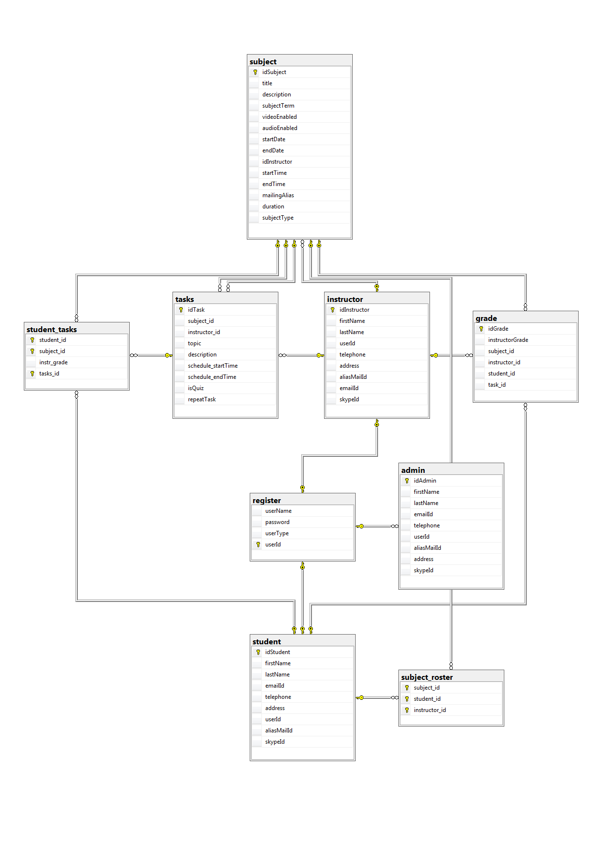

Figure 1. ER diagram – MLA

# SOFTWARE DEVELOPMENT CYCLE

In this chapter, there is a brief description about the Software Development Life Cycle (SDLC), and it shows a path from planning to deployment. Every piece of software is developed with great amounts of planning, without which it is not possible to get the expected outcome. There are different types of SDLC models, and each SDLC model is divided into phases. There is a task associated with each phase, as shown below in Figure 2, which are Planning, Analysis, Design, Implementation, and Maintenance.

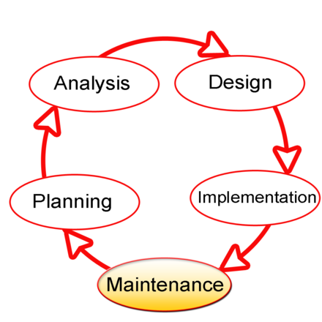

Figure 2. Model of SDLC [2]

The descriptions about all the phases are as follows,

1. **Planning** – In this phase, the developer needs to collect the requirements of the entire system. In MLA, the requirement has been collected from the professor.
2. **Analysis** – In this phase, the developer must analyze the parameters from the planning stage. The developer has to decide how efficiently the product could be developed using different architecture and design patterns. The developer has to keep efficiency in mind, but must also consider reusability and scalability. In the MLA, the 3-tier Architecture and different design patterns like Model-View-Controller (MVC) were used for development of the application.
3. **Design** – In this phase, a developer needs to implement the Graphics User Interface (GUI) of the application. The designer has a vital role which he has to design in terms of User Interface / User Experience (UI/UX). While designing the MLA, the Material Design is used, which is a default design for the Android Platform.
4. **Implementation** – In this phase, a developer needs to implement the entire system with the determined design from the previous phase. The development of this phase is totally dependent on the 3 phases listed above.
5. **Maintenance** – This is the last phase of the SDLC. After completion of the implementation phase, the application should be maintained, and the software should be tested to see if it is bug-free. It might be possible that during the implementation phase, the team might not have considered some valid test cases, which can cause bugs. Because the application can be evolved with a new version, the current version should be scalable to that extent.

As discussed above, there are different SDLC models, with the major difference between each model being the order of the phases. For example, Agile and Waterfall are two different SDLC models. In Waterfall model, it starts with the planning phase and moves to the next phase. It is easy to understand, but for long-term projects it does not work very well. When in an Agile model, it produces ongoing releases of different versions, each with small and incremental changes from the previous release making it an iterative model. The MLA was developed using an Agile Model. The previous chapter provides a brief description about what this application does. Now, in the following chapters, there are detailed discussions about Analysis, Design, and Implementation phases along with MLA.

In the Maintenance phase, a number of testing cycles were executed for the MLA. The bugs were found and resolved.

# ANALYSIS - SYSTEM ARCHITECTURE AND DESIGN PATTERNS

In the previous chapter, various phases of SDLC were discussed. In this chapter, the Analysis phase is discussed. First, there is an introduction about what 3-tier architecture is. Each layer of the 3-tier architecture is explained in depth along with the tools and technologies. In the later part of the chapter, various design patterns and how they are used in MLA are discussed.

## 3-tier Architecture

A 3-tier architecture is a client-server architecture in which the functional process logic, data access, computer data storage, and user interface is developed and maintained as independent modules on separate platforms [3].

The three tiers/layers in a three-tier architecture are:

1. **Presentation Tier:** It occupies the top level and displays information related to services available on a website. This tier communicates with other tiers by sending results to the browser and other tiers in the network [3].
2. **Application Tier:** It is also called the middle tier, logic tier, or business logic. This tier is pulled from the presentation tie, and it controls application functionality by performing detailed processing [3].
3. **Data Tier:** It houses database servers where information is stored and retrieved. Data in this tier is kept independent of application servers or business logic [3].

### **3.1.1 Presentation Layer**

#### **3.1.1.1 Android Studio**

The presentation layer of my application was developed in Android Studio which is Android's official IDE. The purpose that it was built for Android was to accelerate your development and help you build the highest-quality apps for every Android device.

It offers custom-tailored tools for Android developers, including rich code editing, debugging, testing, and profiling tools [4].

A nanodegree program "Developing Android Apps by Google" offered by Udacity is one of the best resources for learning to build Android applications [5].

### **3.1.2 Logic Layer**

#### **3.1.2.1 .NET framework**

.NET framework is a software developed by Microsoft that runs primarily on Microsoft Windows. It includes a large class library named Framework Class Library, and provides language interoperability across several languages [6]. The C# programming language has been used for the application in .NET Framework.

#### **3.1.2.2 RESTful API**

A RESTful API is an application program interface (API) that uses HTTP requests to GET, PUT, POST and DELETE data. A RESTful API breaks down a transaction to create a series of small modules. Each module addresses a particular underlying part of the transaction. This modularity provides developers with a lot of flexibility, but it can be challenging for developers to design from scratch. Currently, the models are provided by few popular cloud data management interfaces [7]. Amazon EC2 has been used which is explained below.

#### **3.1.2.3 Amazon EC2**

Amazon Elastic Compute Cloud (Amazon EC2) is a web service that provides secure, resizable compute capacity in the cloud. It is designed to make web-scale cloud computing easier for developers [8].

Amazon EC2’s simple web service interface allows you to obtain and configure capacity with minimal friction. It provides you with complete control of your computing resources and lets you run on Amazon’s proven computing environment. Amazon EC2 reduces the time required to obtain and boot new server instances to minutes, allowing you to quickly scale capacity, both up and down, as your computing requirements change. Amazon EC2 changes the economics of computing by allowing you to only pay for the capacity that you actually use. Amazon EC2 provides developers with the tools to build failure resilient applications and isolate them from common failure scenarios [8].

### **3.1.3 Data Layer**

#### **3.1.3.1 Microsoft SQL Server Management Studio**

SQL Server Management Studio (SSMS) is an integrated environment for managing any SQL infrastructure. Use SSMS to access, configure, manage, administer, and develop all components of SQL Server, Azure SQL Database, and SQL Data Warehouse. SSMS provides a single comprehensive utility that combines a broad group of graphical tools with a number of rich script editors to provide access to SQL Server for developers and database administrators of all skill levels [9].

#### **3.1.3.2 Amazon RDS**

Amazon Relational Database Service (Amazon RDS) makes it easy to set up, operate, and scale a relational database in the cloud. It provides cost-efficient and resizable capacity while automating time-consuming administration tasks such as hardware provisioning, database setup, patching and backups. It frees you to focus on your applications, so you can give them the fast performance, high availability, security and compatibility they need [10].

## Design Patterns

In the Software Engineering field, design pattern plays an essential role while developing a piece of software. Design pattern resolves the most common problems faced during the development cycle. It also provides a reusable solution to problems, either description or template, depending on the problem. It is categorized mainly into 3 categories,

1. **Creational Pattern:** In Object Oriented Programming, this pattern helps to create an object in a suitable manner. The singleton pattern and the builder pattern are examples of this pattern.
2. **Structural Pattern:** This pattern helps to identify a relationship between classes and subclasses, and between objects who share common properties such as the adapter pattern, and the composite pattern.
3. **Behavioral Pattern:** TheCreational and Structural patterns focuses on creation and arrangement of the entities, while the Behavioral pattern focuses on communication between them, such as the Command pattern, and the Observer pattern.

The design patterns that were used during the development are listed below.

### **3.2.1 MVC Design Pattern**

In any application, there are always 3 most important components. The first major component is data. Data needs to be modified frequently, so we need an interface to view and modify the data. And to modify the data we need operations to perform on the data to make it useful. The MVC design pattern has been used to address this situation in the presentation layer of my application.

As shown in Figure 3, the MVC pattern is as follows:

1. The **model** represents the data, and does nothing else. The model does not depend on the controller or the view [11].
2. The **view** displays the model data, and sends user actions (e.g. button clicks) to the controller. The view can:
   * Be independent of both the model and the controller; or
   * Actually **be** the controller, and therefore depend on the model [11].
3. The **controller** provides model data to the view, and interprets user actions such as button clicks. The controller depends on the view and the model. In some cases, the controller and the view are the same object [11].

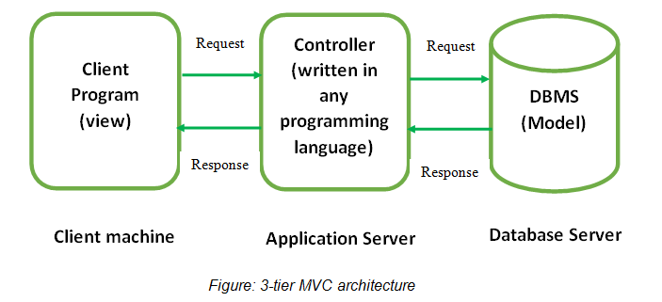

Figure 3. 3-tier MVC architecture [12]

### **3.2.2 Builder Pattern**

As discussed above, this pattern falls under Creational Pattern. As the application becomes more sophisticated, the number of classes, objects, and functions are increased. The class can create different representations of a complex object. This can be achieved with encapsulation and delegation.

In the MLA, Restrofit.Builder library was used for converting HTTP API into a Java interface. In the source code, an interface, APIInterface.java, has been created. This interface is used by API.java file. When an API is called from source code, a method getClient() has been called from API.java, which returns an object of APIInterface. This method allows for the encapsulation and delegation of the creation of objects.

### **3.2.3 Adapter Pattern**

As we discussed above, this pattern falls under Structural Pattern. The Adapter design pattern allows incompatible classes to work together by converting the interface of one class into an interface expected by the clients [13].

The Adapter design pattern describes how to solve the following problems:

* Define a separate Adapter class that converts the (incompatible) interface of a class (Adaptee) into another interface (Target) clients require [13].
* Work through an Adapter to work with (reuse) classes that do not have the required interface [13].

In MLA, this pattern was used extensively to connect the relationship between AdapterView and Dataset inside the view. ListView is used for displaying various data. Figure 4 shows that an Adapter works like a bridge.

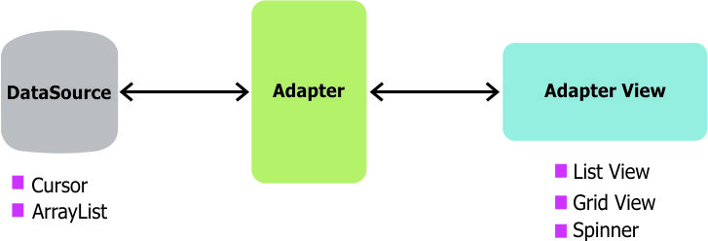

Figure 4. Adapter design pattern on Android platform [14]

### **3.2.4 Publisher-Subscriber Pattern**

As discussed above, this pattern falls under Behavioral Pattern. In this pattern senders of messages, or publishers, do not program the messages to be sent directly to specific receivers, or subscribers, but instead categorize published messages into classes without the knowledge of which subscribers, if there are any [15].

The advantages of this pattern are,

1. Loose coupling
2. Scalability

The disadvantage of this pattern is,

1. Message delivery issue

In Android Operating System, the applications can send or receive the broadcast message, and the developer needs to register the event in the code to trigger a message. In the MLA, this design pattern was used with AlartTaskIntentService.java and MLAScheduleAddFragment.java. When one schedule is added for a subject, a new event is subscribed to show a notification to the logged-in user about the scheduled class 10 minutes before the class starts. This is an ideal way to use this design pattern.

To conclude this chapter, the Analysis phase is an essential prior step before starting to design phase. It provides a solid foundation to the software which makes it robust. In the next chapter, there is more information about the Design phase.

# DESIGN – MAKING GUI

In the previous chapter, the 3-tier architecture and various design patterns have been discussed, and in this chapter the Design phase from SDLC will be discussed. In this phase, the design of the application is executed. This involves arranging for the required information to be displayed in the screens, transitioning from one screen to another screen, and passing of information from one screen to another screen. First, a step-by-step process for installing Android Studio is shown. Second, a Material Design metaphor is discussed and followed by a process of designing GUI, which will be explained with examples.

## Setup an Android Source Code

To setup the source code, follow the steps below,

1. Go to <https://developer.android.com/studio/index.html>, and download the latest version of Android Studio.
2. Install the IDE on your local machine.
3. To develop a project from scratch follow steps 3-6, if the reader has an existing source code then jump to step 7. Open Android Studio. Figure 5 shows a welcome screen. Select “Start a new Android Studio Project”.

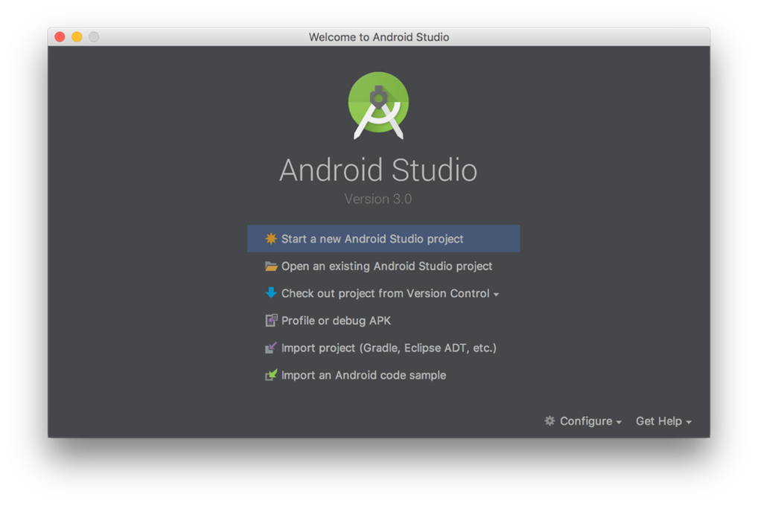

Figure 5. Welcome Android Studio 3.0

1. As shown in Figure 6, add application name, company name, project location, and press “Next”.

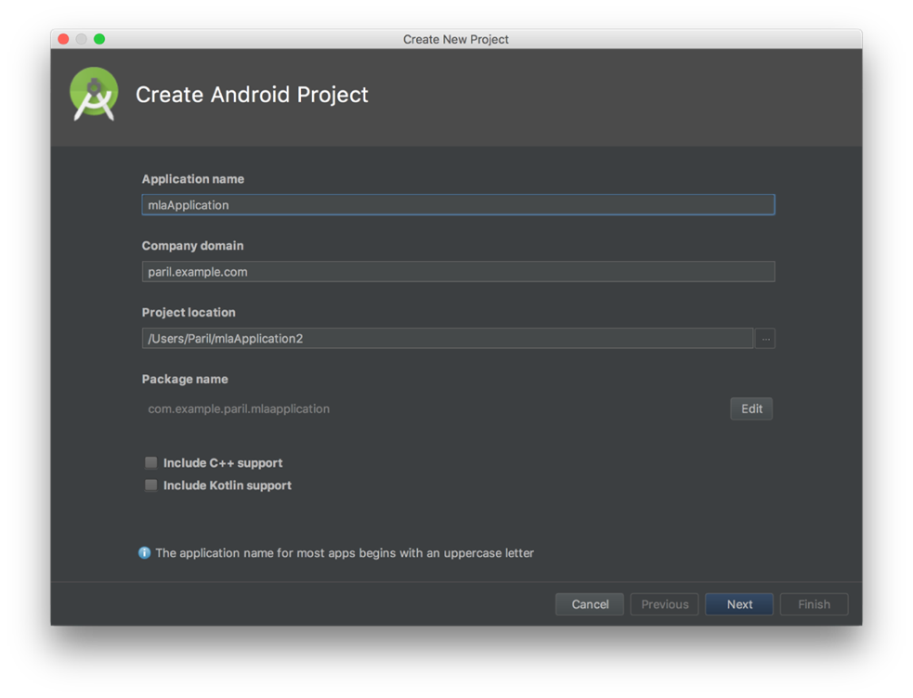

Figure 6. Create an Android project

1. As shown in Figure 7, select “Phone and Tablet” for Target Android Devices and press “Next.” The MLA has been configured to support Android 6.0 (Marshmallow).

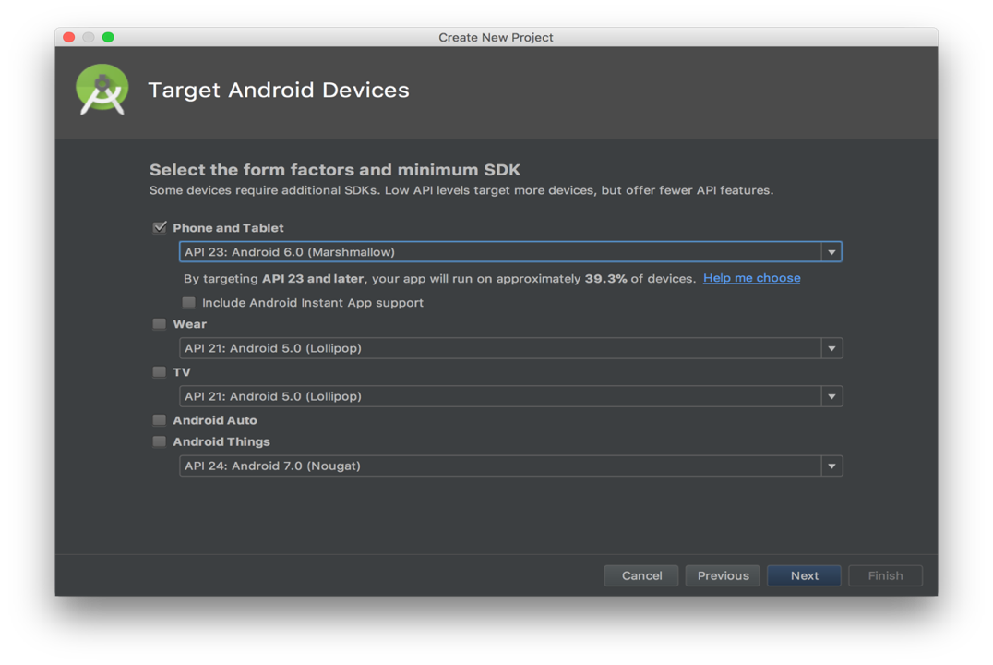

Figure 7. Select a target Android device

1. The Android Studio provides suggestions for different templates to start a project. As shown in Figure 8, select a suitable activity, or a place where a user can create GUI of a screen, for a project. For MLA, the Empty Activity Template has been selected. Following that step, give a proper name to the activity as shown in Figure 9.

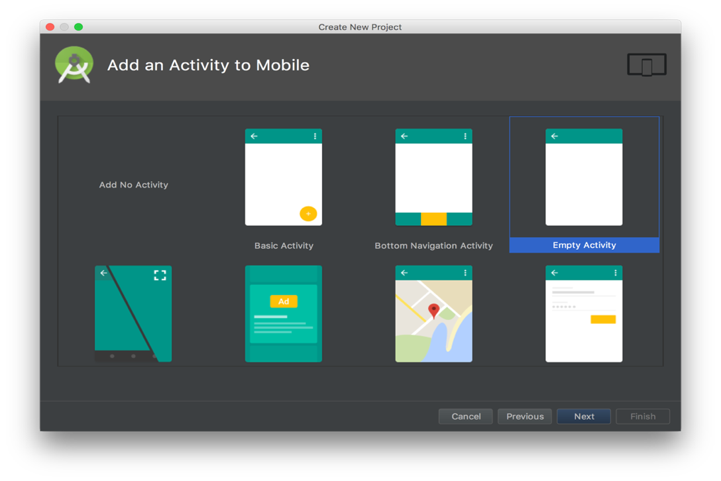

Figure 8. Select an activity

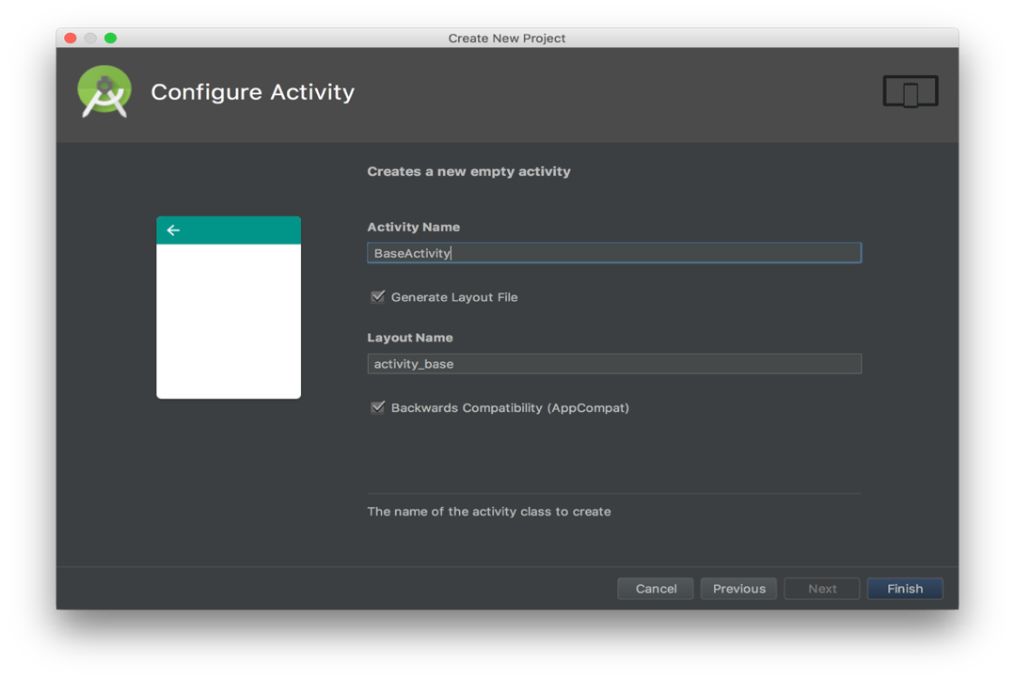

Figure 9. Configure the activity

1. For an existing project, get the source code and select the option “Open an existing Android Studio Project.”
2. The IDE installs necessary dependencies and import settings.
3. To run the application in Emulator, first set up a new virtual device.
4. From the Android Virtual Device (AVD) manager on the Toolbar, create a new virtual device. This virtual device provides a testing environment similar to a real device. The examples of real device are Nexus 6, Pixel XL, Pixel XL 2, etc.

## Material Design

At the time of development, the application should have consistency in terms of design. An Android operating system supports the Material Design framework by default. The Material Design provides a rich user experience, and user interface components which can be integrated with the Android application. The design is relying on following principles [16],

1. Material is the metaphor.
2. The design should create hierarchy, meaning, and focus. The color choices, edge-to-edge imagery, typography, and intentional white space create a bold and a live graphics interface.
3. Motion provides meaning.

So, as per the above rules, from different integral parts of the components like surface, edges and lights could be used appropriately for designing. As shown in Figure 10, the material design uses three dimensions, X, Y and Z. The 3rd dimension, Z, is used for creating shadow and light in the design.



Figure 10. 3-D Material Design [16]

The adoption rate in the market is huge, so users know how to use such components in terms of user experience. The application uses a material design as a primary design standard.

## Design a GUI in Android

Designing a GUI in Android is a meticulous process. As shown in Figure 11, a developer needs to identify what components that a screen design requires. Figure 11 illustrates a sample Login screen of MLA. There are two TextView and a Button. Following that, the developer has to use respective components, which could either be Default (provided by UI library of Android SDK) or Custom (developed using default components). Then the developer has to decide the layout of the screen. This means the coordinates of the components relative to each other or in parent view, or a view which contains other views. In order to design a screen / an activity in Android, a developer needs to use eXtensible Markup Language (XML). So, the design file has an extension “.xml.”

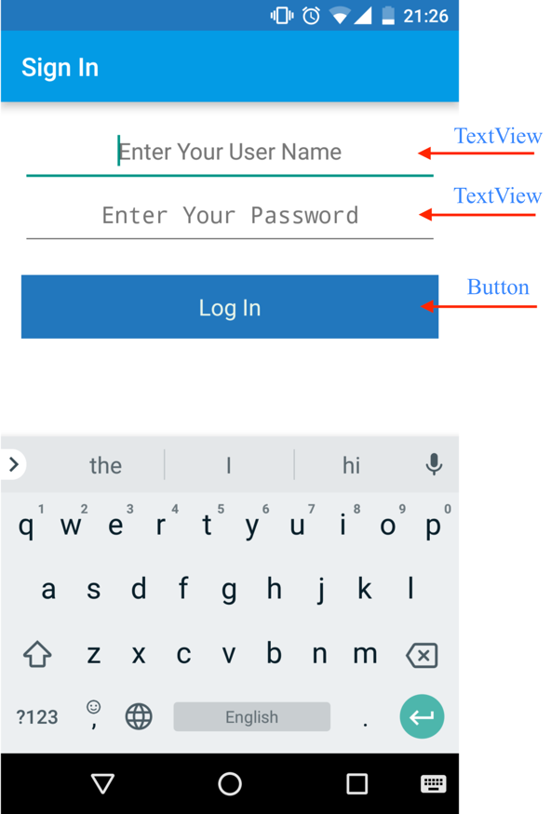

Figure 11. Components in Login Screen

Figure 12 illustrates a sample Grade screen within MLA. This is another example for identifying components from the screen. Figure 12 shows an XML implementation of the Grade Screen, but it is not the full XML representation of the entire grade screen, as it only shows the 1st TextView and the 1st Spinner with its TextView. An Android Operating System has different layout components for showing other sub views. For example, Linear Layout is a view group that aligns all children in a single direction, vertically or horizontally [17], while Relative Layout is a view group that displays child views in relative positions. The position of each view can be specified as they relate to sibling elements (such as to the left-of or below another view) or in positions relative to the parent Relative Layout area (such as aligned to the bottom, left or center) [17]. In Figure 12, most of the components are arranged in Linear Layout; however, “Select Subject”, TextView, and “CSc 239,” Spinner are arranged in Relative Layout. In Figure 13, under XML tag, the texts with “android:xxxx” show attributes for a specific component. The attributes define a state of the component. For example, first TextView, needs a text/value “To edit a grade to swipe,” so this can be designed by adding the attribute “android:text.” In order to decide the height and width of the components, the “layout_width” and “layout_height” attributes can be used. The attribute value for the TextView is “wrap_content,” that means the width and the height of the TextView depends on the amount of content it has, making the size of the TextView dynamic.

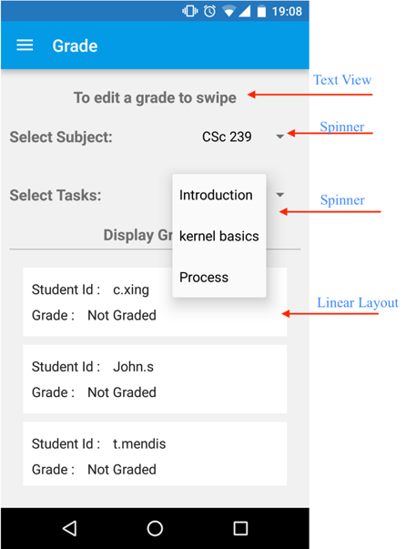

Figure 12. Components of Grade screen

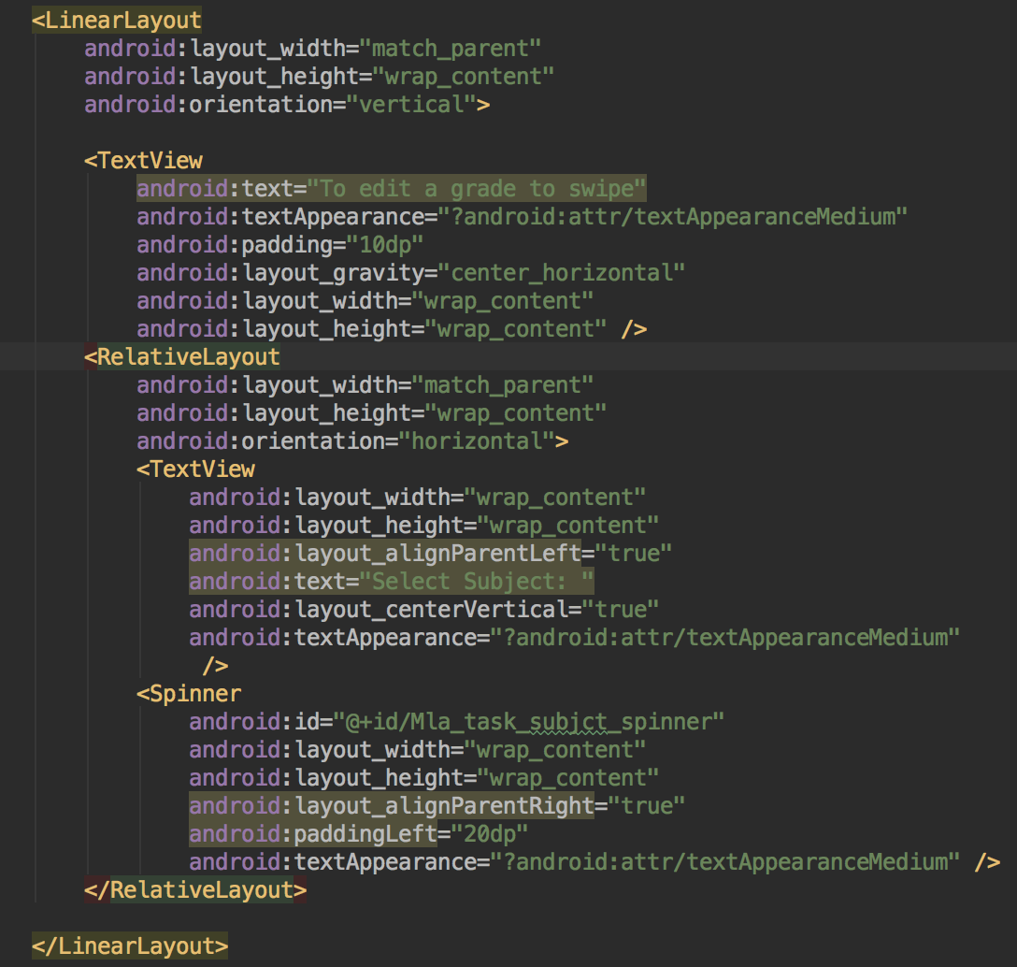

Figure 13. XML representation of Grade screen

# IMPLEMENTATION

In the previous chapter, the brief about designing in Android was explained. This chapter shows a functional implementation once the design is ready. For MLA, the implementation phase is divided in 2 parts: 1.) Front End, and 2.) Server End.

## Front End Implementation

The implementation of the front end contains logical flow of the application. The implementation files are written in Java. Below the logical flow will be explained screen-by-screen.

### **5.1.1 Login Screen**

The first component is the login screen of the application, as shown in Figure 14. The user can see this screen right after they install the application and open it for the very first time. Once the user enters a correct username and password, the user will be navigated to the home screen as per the role type (admin, instructor or student). The next time the user opens the application, they will see the Home screen instead of the Login screen unless the user logged out.

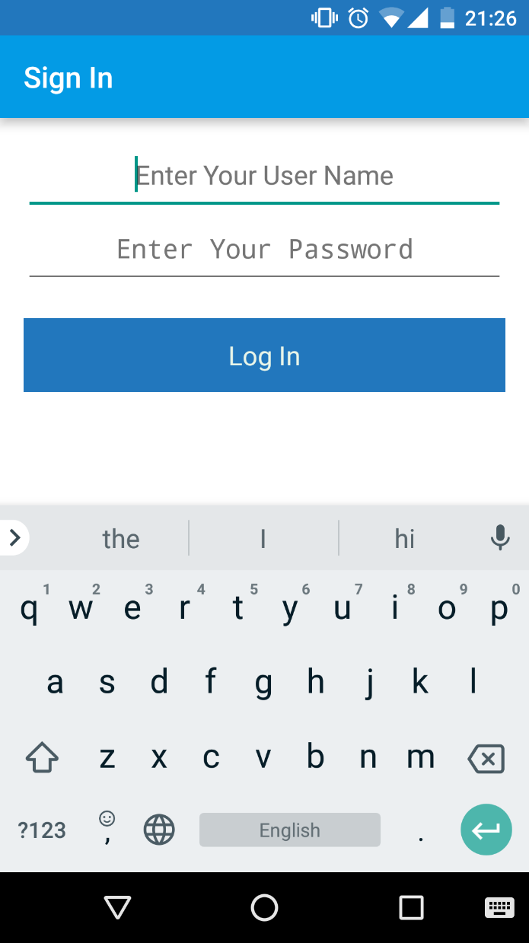

Figure 14. Login screen

On clicking “Log In” button, *setOnClickListener****(***) is called. This method checks the validation first, if any of the Text Views are empty then returns an error, else it calls API, @GET("api/Register/GetRegisterAuth") with parameters, username and password. As shown in Figure 15 and details from Chapter 3, the Builder design pattern is used in the code to call the API.

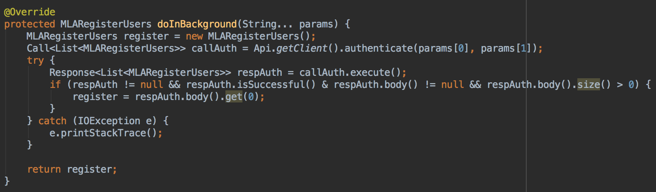

Figure 15. Snippet of an API call from MLALoginActivity.java

### **5.1.2 Admin**

After logging in as an admin, the user is navigated to the Home screen. The admin can see 3 quick options, 1.) Courses, 2.) Students, and 3.) Instructors. As an admin, the user has full privileges. As shown in Figure 16, more functionalities can be accessed by pressing “Sidebar menu”.

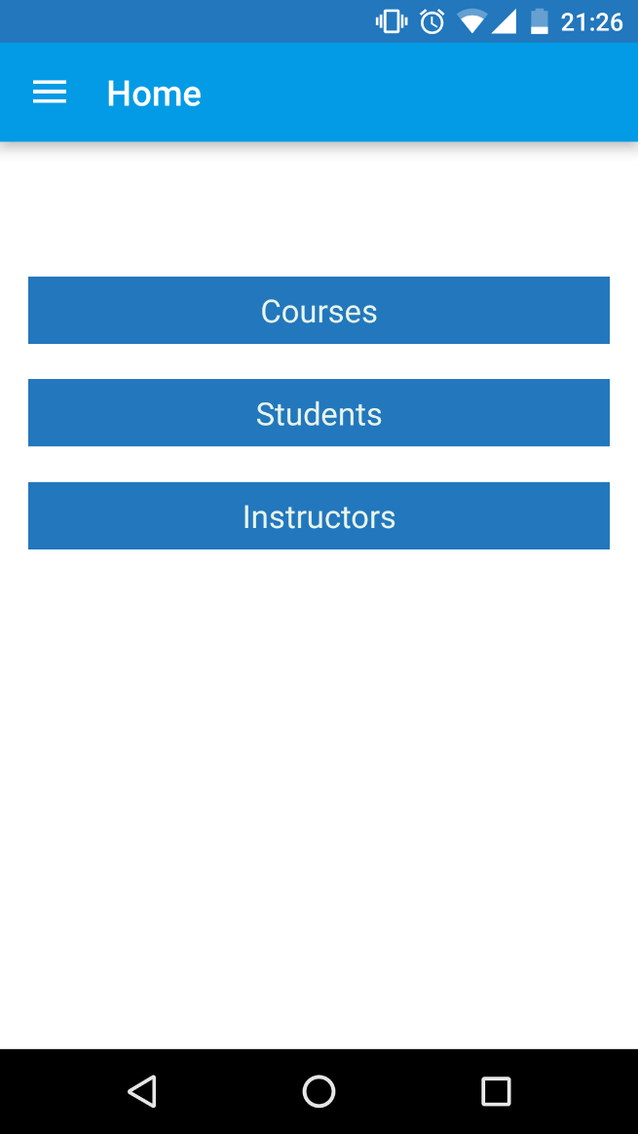 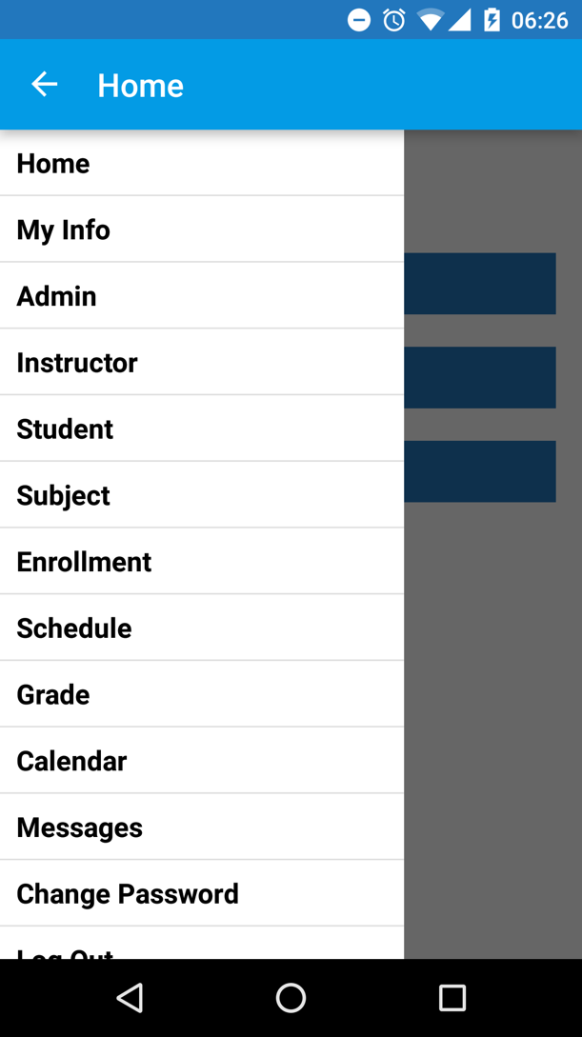

Figure 16. Admin Home screen and privileges

After successfully logging in, the Home screen appears with different views and privileges according to user type. If the user is an admin then it simply shows 3 buttons. Also, the implementation file contains the code snippet for configuring the “Sidebar Menu.” From MlaHomeActivity.java, *onCreate()* method calls *onHomeClick()* method, which is responsible for configuration of Home screen according to user type.

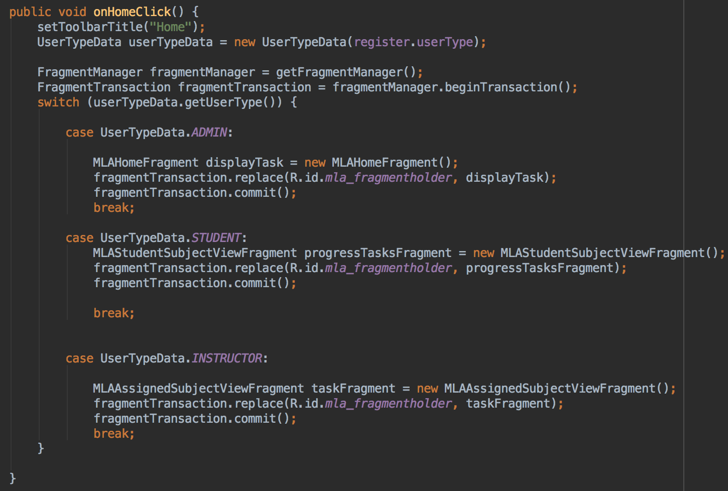

Figure 17. Snippet of configuring Home Screen from MLAHomeActivity.java

#### **My Information**

The Figure 18 shows the detailed information of the current admin who is logged-in.

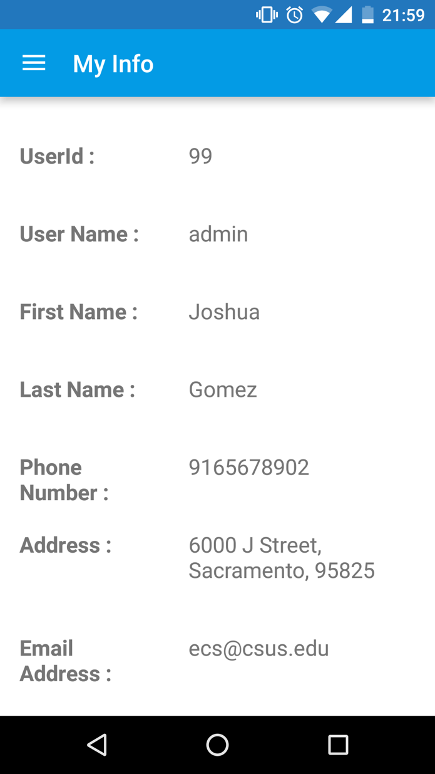

Figure 18. Admin information

#### **Add a new admin**

To add a new admin, a user needs to log in as an admin, since only an admin has the privilege to add other admins. To add an admin, go to “Admin” tab from the “Sidebar menu”. Here the admin can see a list of all other admins present inside the database. Then the admin needs to click on “+” button at the right bottom of the screen, which leads the user to the Add Admin screen. Here the admin must add all the valid data (validation for 10 digits of phone number, an email address has been taken care by the application) in the respective fields and then press “✓”.

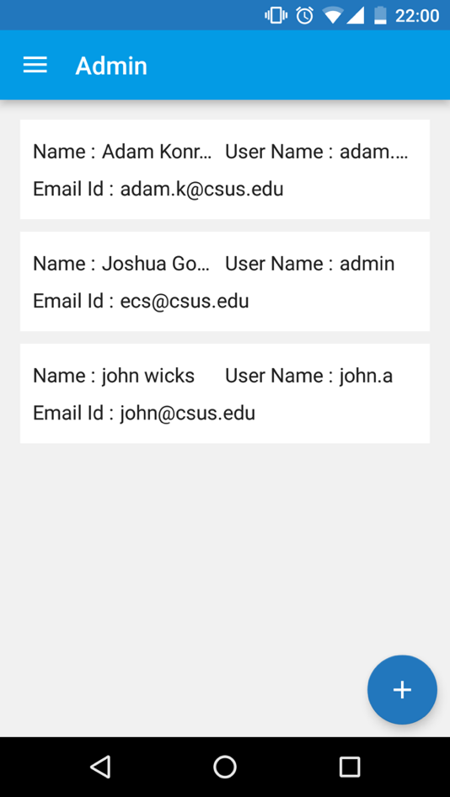 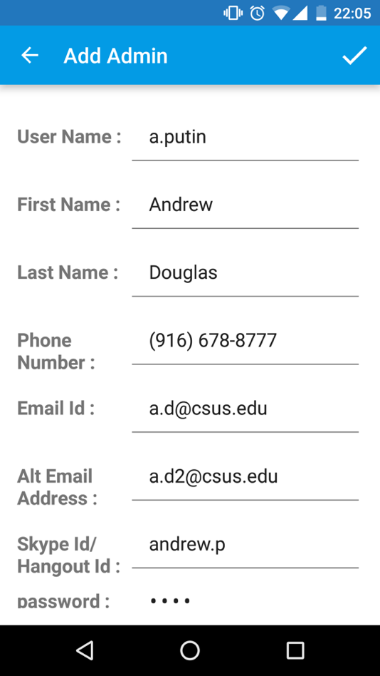

Figure 19. Add an admin and its information

Upon clicking the “+” button, the *setOnClickListner()* method will be called from MLAAdminViewFragment.java, which navigates a user to the MLAViewAdminActivity.java file for adding a new admin. Form a reusability perspective, edit admin and add admin functions shared the same implementation file.

As illustrated in Figure 20, this is a snippet of fetching a list of admins from the Database. The API is @GET("api/Admin/GetAllAdmin") with no parameter.

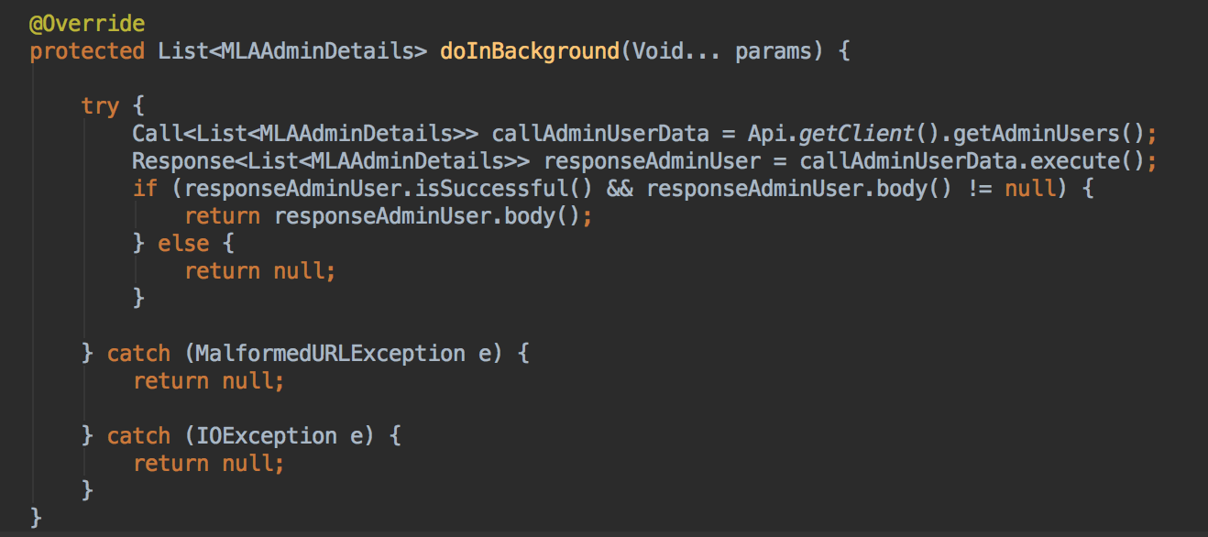

Figure 20. Snippet of fetching a list of admins from MLAAdminViewFragment.java

As shown in Figure 21 this code is used for adding a new admin in the Database. The API is @POST("api/Register/PostAddInstructor") with all the required fields as the parameters.

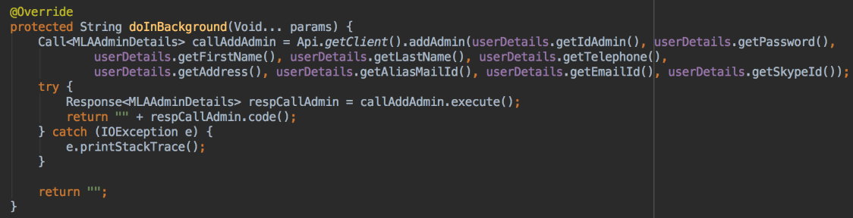

Figure 21. Snippet of adding an admin from MLAViewAdminActivity.java

#### **Edit and Delete an admin**

As shown in Figure 22, an admin can edit and delete other admins. To edit or to delete an admin, the user should swipe left on an item of listview. The user will see 2 options, 1.) Edit admin, and 2.) Delete admin. On selecting the first button (from left), the user is navigated to the edit admin screen, where the user can see the information for the admin. After editing the necessary and valid information, the user needs to press “✓”. In case the user wants to discard the changes, the user can press the “x” button. When selecting the second button (from left), the user can delete an existing admin.

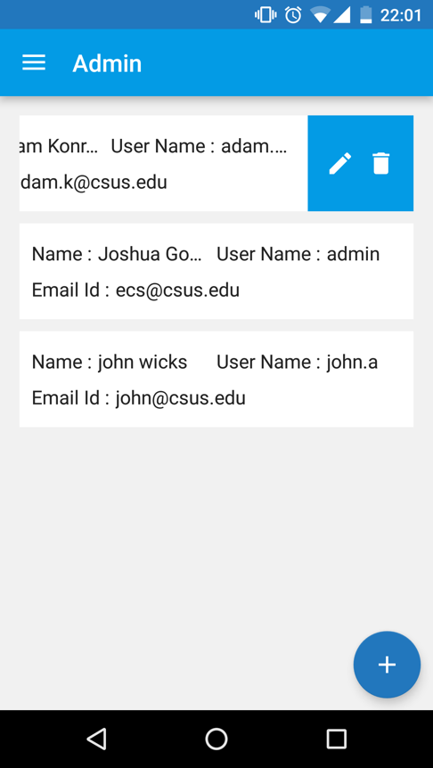 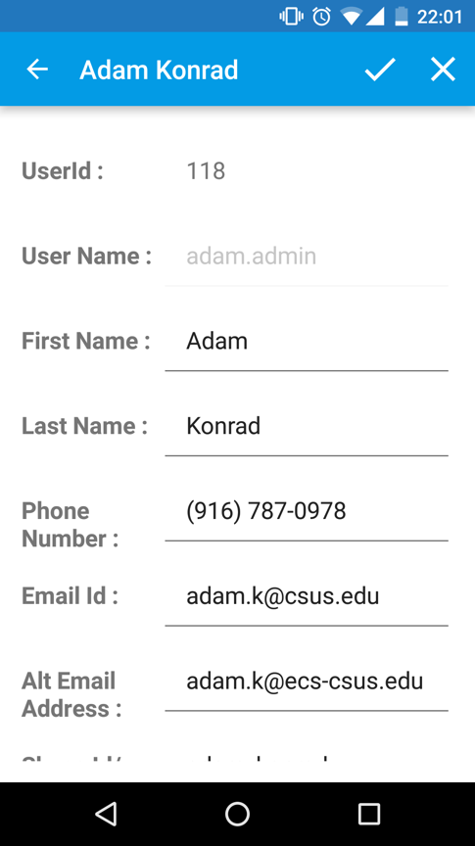

Figure 22. Editing an information of an admin

As shown in Figure 23, the code snippet is used for removing an existing admin. The API is @POST("api/DeleteAdmin/PostAdminRmv") with the admin username as a parameter.

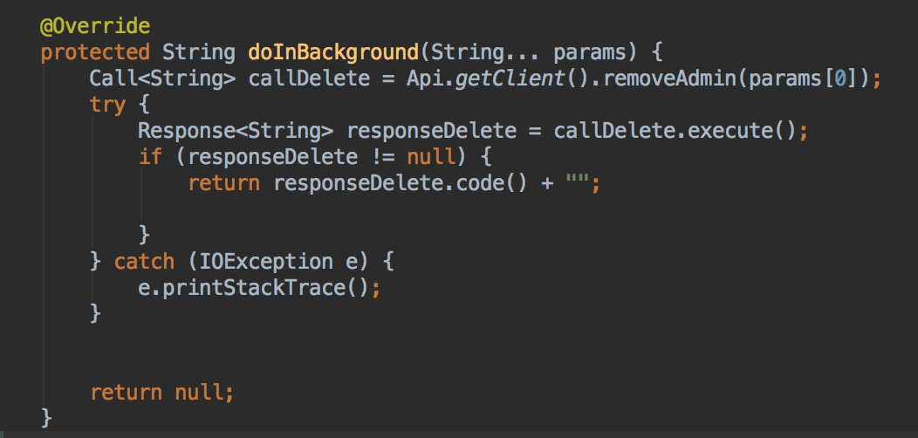

Figure 23. Snippet of removing an admin from MLAAdminViewFragment.java

As shown in Figure 24, the code snippet is used for updating information of an existing admin. The API is @POST("api/Admin/PostAdminUpdate") with required parameters.

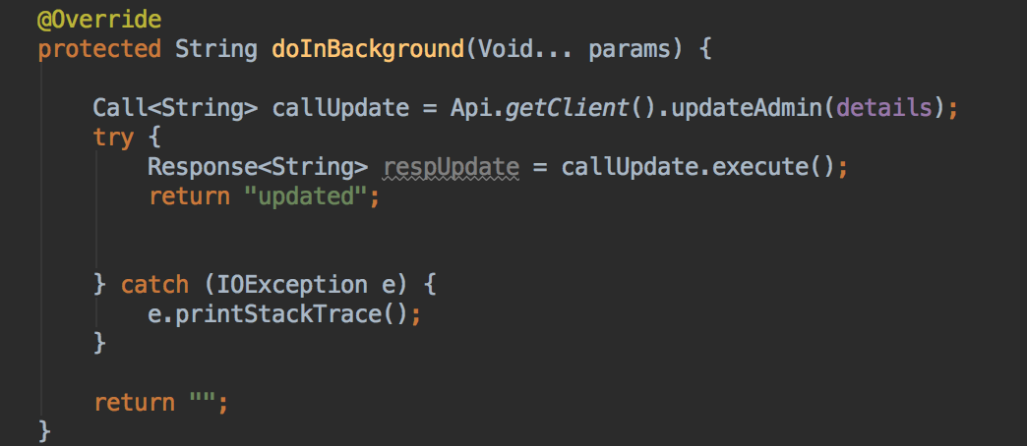

Figure 24. Snippet of editing an information of an admin from MLAViewAdminActivity.java

#### **Add a new instructor**

Figure 25 shows an example of adding a new instructor. An admin can only add a new instructor or edit the information of existing instructors. To add a new instructor, go to “Instructor” tab from the “Sidebar menu.” Here, the admin can see a list of all the instructors present in the database. Then the admin needs to click on the “+” button at the right bottom. This leads to the user to the add instructor screen. Here, the admin must add all the valid data (validation is done automatically for the application that ensures that 10 digits of a phone number, and a valid email address were entered correctly) in the respective fields and then press “✓”.

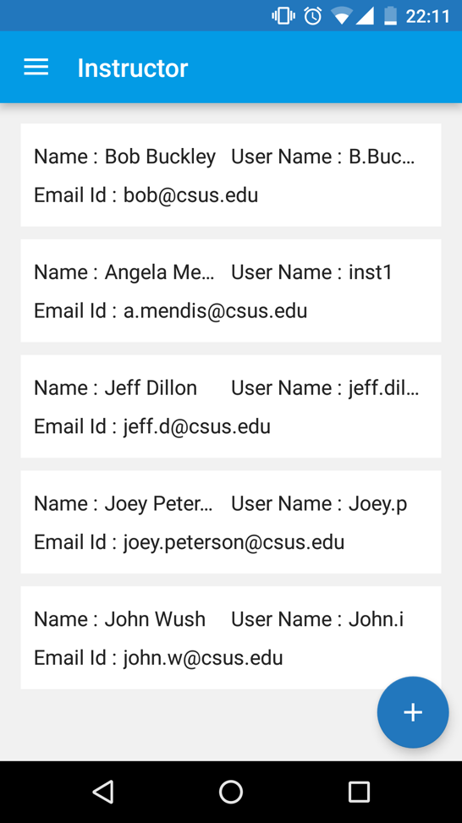 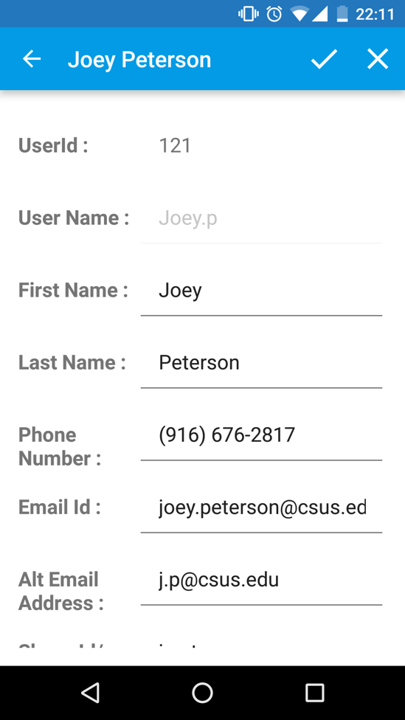

Figure 25. Adding a new instructor and a list of instructors

Upon clicking the “+” button, the *setOnClickListner()* method will be called from MLAInstructorViewFragment.java, which navigates a user to MLAViewInstructorActivity.java file for adding a new instructor. From a reusability perspective, the Edit Instructor and Add Instructor functions shared the same implementation file.

Below in Figure 26 is a snippet of fetching a list of instructors from the Database. The API is @GET("api/Instructor/GetAllInstructor") with no parameter.

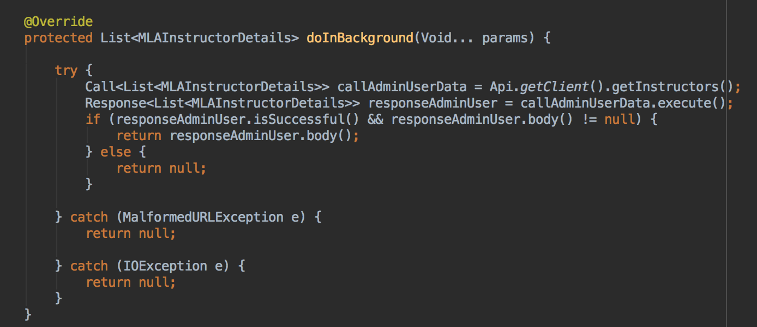

Figure 26. Snippet of fetching a list of Instructors from MLAInstructorViewFragment.java

As shown in Figure 27, this code is used for adding a new admin in the Database. The API is @POST("api/Register/PostAddInstructor") with all the required fields as the parameters.

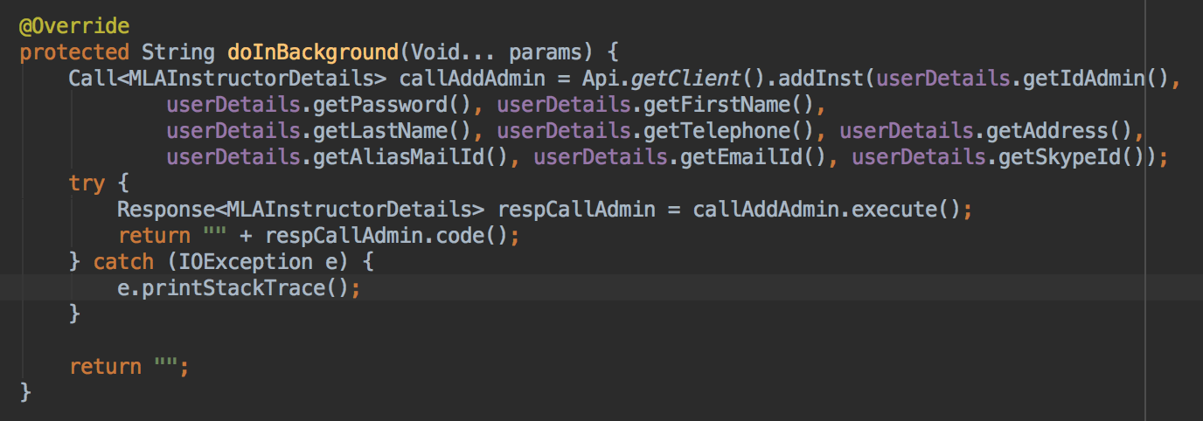

Figure 27. Snippet of adding an instructor from MLAViewInstructorActivity.java

#### **Edit and Delete an instructor**

As shown in Figure 28, an admin can edit and delete instructors. To edit or to delete an instructor, the user should swipe left on an item of listview. The user will see 2 options, 1.) Edit instructor, and 2.) Delete instructor. On selecting the first button (from left), the user is navigated to the edit instructor screen, where the user can see the information for the instructor. After editing the necessary and valid information, the user needs to press the “✓”. In case the user wants to discard the changes, the user can press the “x” button. When selecting the second button (from left), the user can delete an existing instructor.

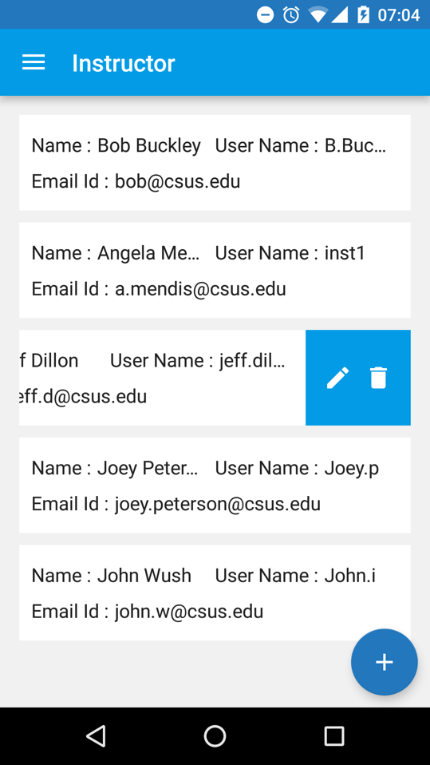 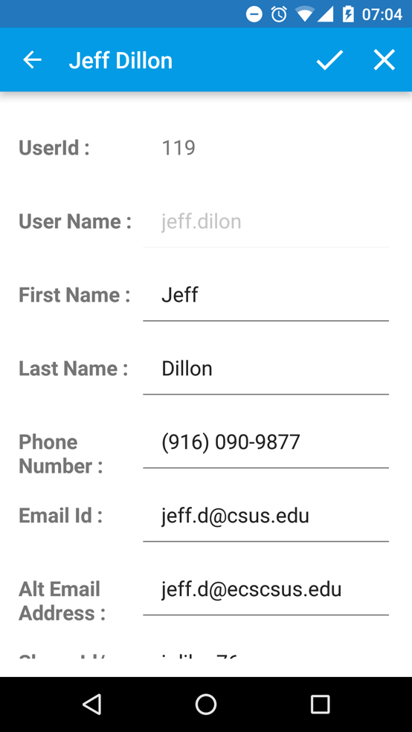

Figure 28. Adding an instructor

As shown in Figure 29, the code snippet is used for updating the information of an existing instructor. The API is @POST("api/Instructor/PostInstructorUpdate/") with required parameters.

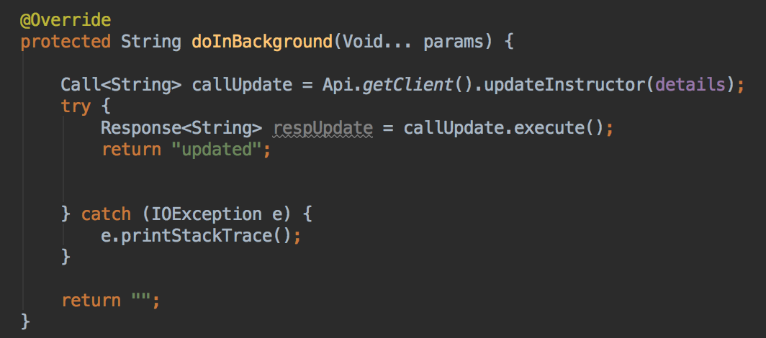

Figure 29. Snippet of editing an information of an instructor from MLAViewInstructorActivity.java

As shown in Figure 30, the code snippet is used for removing an existing admin. The API is @POST("api/DeleteInstructor/PostInstructorRmv") with the instructor username as a parameter.

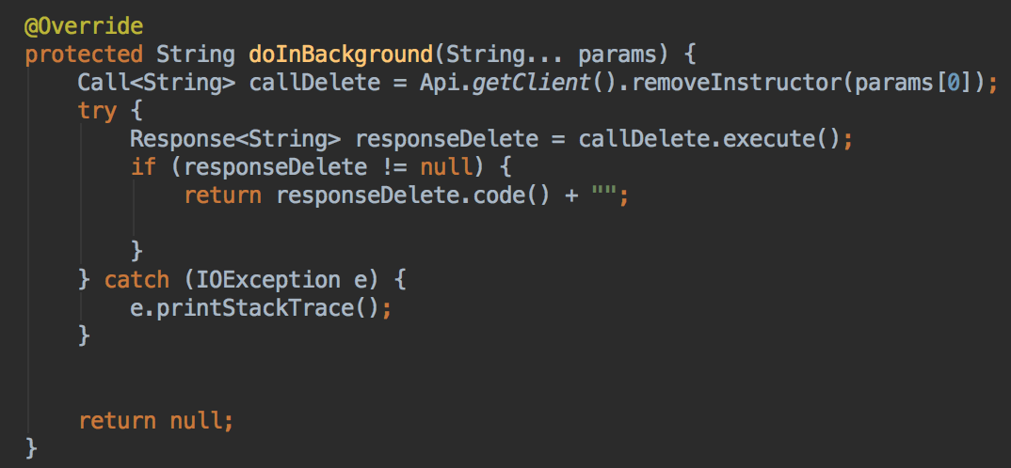

Figure 30. Snippet of removing an instructor from MLAInstructorViewFragment.java

#### **How to add a student**

Figure 31 shows an example of adding a new student. An admin can only add a new student or edit the information of the existing student. To add a new student, go to “Student” tab from the “Sidebar menu.” Here the admin can see a list of all the students present into the database. Then the admin needs to click on the “+” button at the right bottom. This leads the user to the Add Instructor screen. Here the admin must add all the valid data (validation for 10 digits of phone number, an email address has been taken care by the application) in the respective fields and then press “✓”.

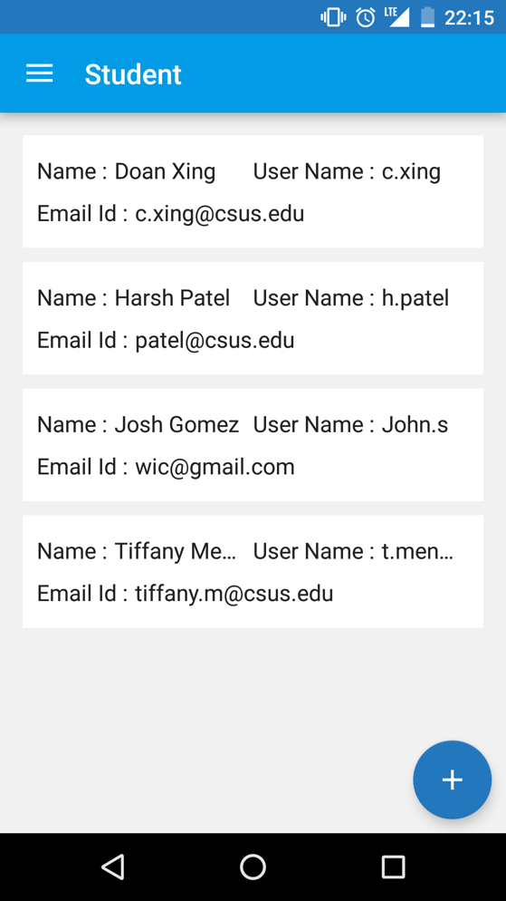 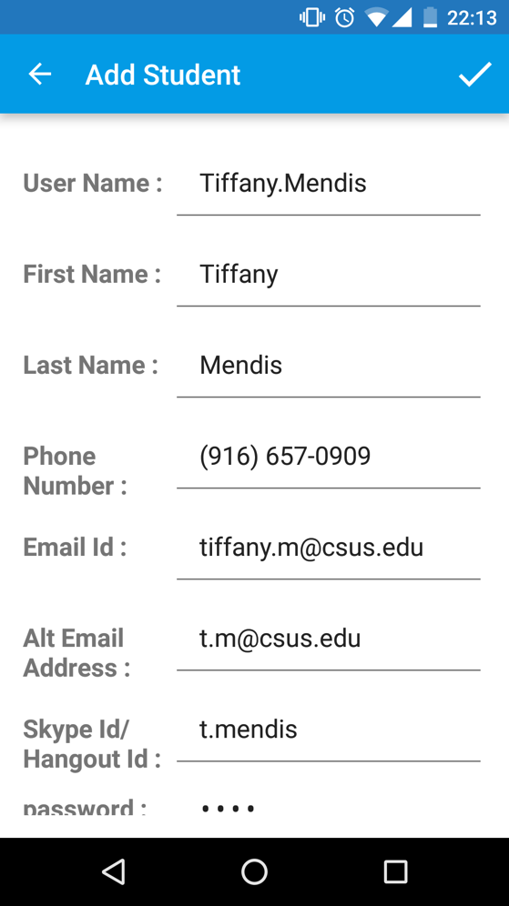

Figure 31. Adding a new student

#### **How to edit and/or delete a student**

In Figure 32 below, in the instance there are no students, then an admin will see an “Empty View” with a message that states that there are no students enrolled. Also in Figure 32, there is an example of the process of editing information of a student.

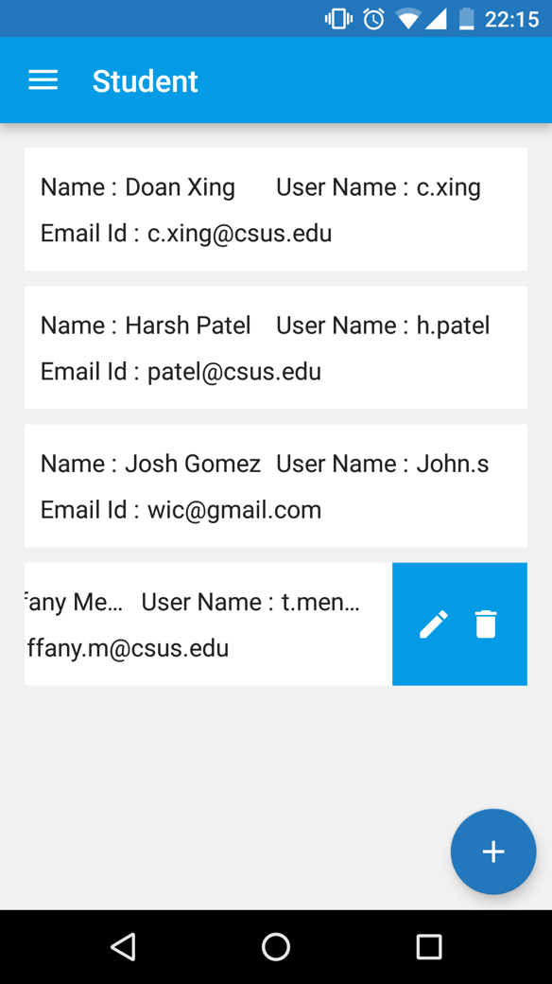 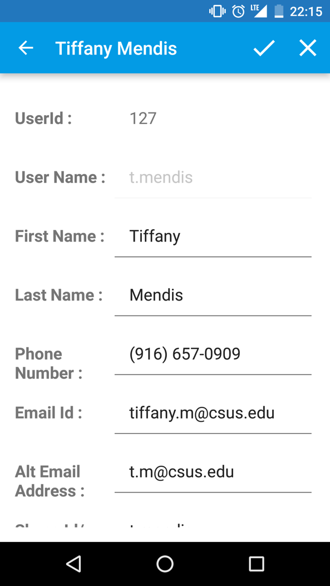

Figure 32. Editing an information a student

The API call for displaying a list of students, adding a new student, removing an existing student, and editing information of a student have the same process as shown above for the admin and instructor; although the passing parameters are different.

As shown in Table 2, There is a list of implementation files, the end point of the API, and the respective purpose of the API.

|  |  |  |  |
| --- | --- | --- | --- |
| **#** | **Implementation File** | **Purpose** | **API** |
| 1 | MLAStudentView  Fragment.java | Displaying Students | @GET("api/Student/GetAllStudent") |
| 2 | MLAViewStudentActivity.java | Adding a new student | @POST("api/Register/PostAddStudent") |
| 3 | MLAViewStudentActivity.java | Editing an information of a student | @POST("api/Student/PostStudentUpdate/") |
| 4 | MLAStudentView  Fragment.java | Removing a student | @POST("api/DeleteStudent/PostStudentRmv") |

Table 2. Implementation files and API end points for Students

#### **Add a new subject**

It is obvious that an admin has the full privilege of adding a new subject, editing the detail of the existing subject and removing the course from the catalogue. While the admin has full rights, the instructor and the student can only see the subjects. To add a new subject, the admin needs to go to the “Subject” tab from the “Sidebar menu” or from the Home screen go to “Courses”. Here the admin can see a list of all the subjects presents in the catalogue. Then the admin needs to click on the “+” button at the right bottom. The admin is then redirected to the Add Subject screen. Here the admin can add the title, the description, the instructor from the existing instructors etc. When the admin is finished, he/she can then press “✓”.

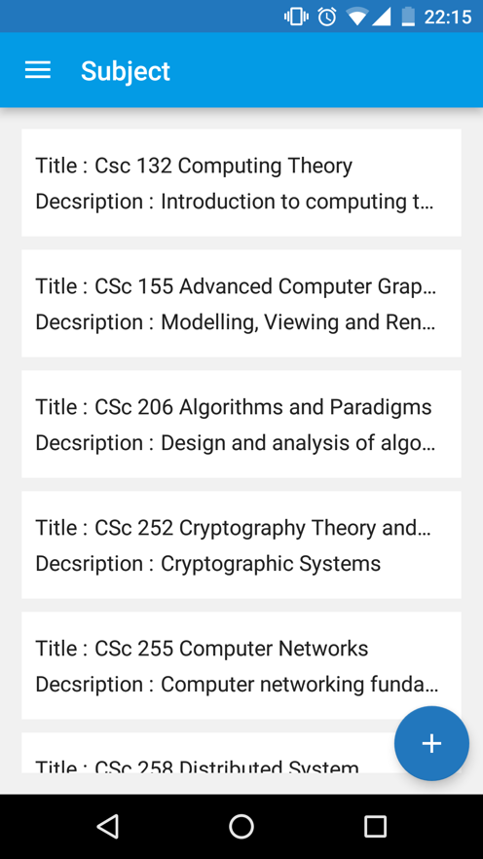 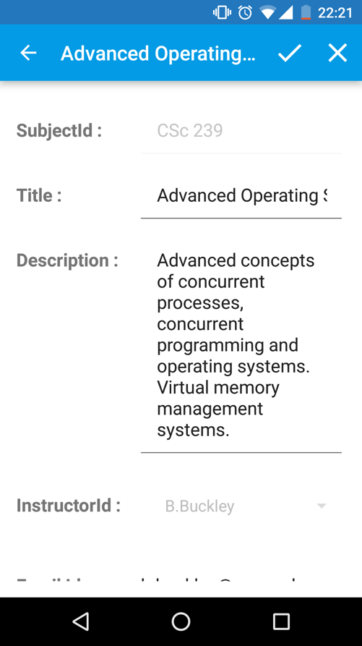

Figure 33. Adding a subject

#### **How to edit and/or delete a subject**

As an admin, the user can edit and/or delete a subject. As seen in the Figure 34, to edit or to delete a subject, the user should swipe left on an item in the list view. The user will see 2 options, 1.) Edit subject, 2.) Delete subject. On selecting the first button (from left), the user is navigated to the edit subject screen, where the user can see the information on the subject. After editing the necessary and valid information, the user needs to press “✓”. In case the user wants to discard the changes, the user needs to press the “x” button. When selecting the second button (from left), the user can delete an existing subject, which removes a subject from the catalogue.

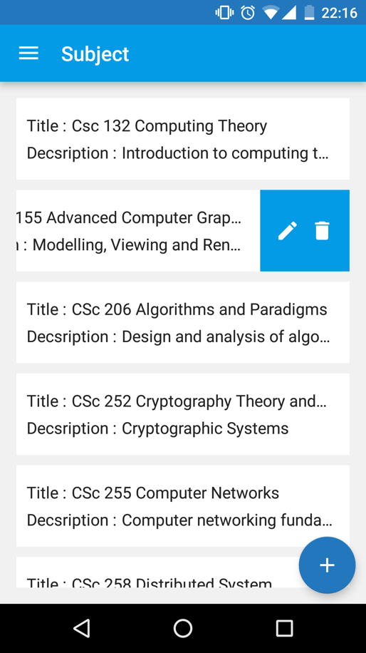 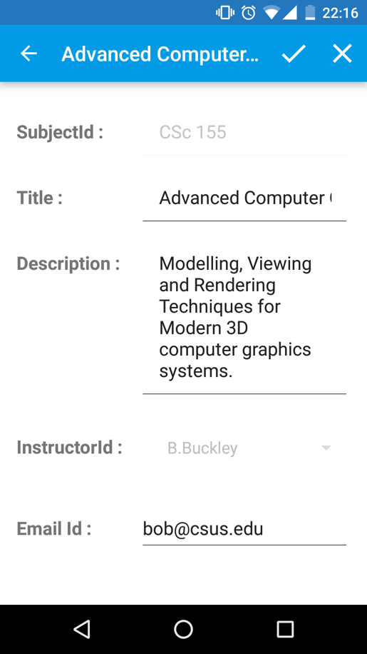

Figure 34. Editing information of a subject / Deleting a subject

The API call for displaying a list of subjects, adding a new subject, removing an existing subject, and editing information of a subject has the same procedure as shown above for the admin and instructor; although the passing parameters are different.

Table 3 shows a list of implementation files, end point of API, and the respective purpose of the API,

|  |  |  |  |
| --- | --- | --- | --- |
| **#** | **Implementation File** | **Purpose** | **API** |
| 1 | MLASubjectViewFragment.java | Display Subject | @GET("api/Subject/GetAllSubject") |
| 2 | MLAViewSubjectActivity.java | Add a new Subject | @POST("api/Subject/PostSubject") |
| 3 | MLAViewSubjectActivity.java | Edit an existing Subject | @POST("api/SubjectUpdate/PostSubjectUpdate") |
| 4 | MLASubjectViewFragment.java | Remove a Subject | @POST("api/SubjectRmv/PostSubjectRmv") |

Table 3. Implementation files and API end points for Subjects

#### **How to enroll a student**

As seen in Figure 35, the admin can enroll and drop the students from courses. This is one of the essential features of the application. When an admin press “Enrollment” from “Sidebar menu”, there are 3 options: 1.) Enroll, 2.) Display, and 3.) Drop.

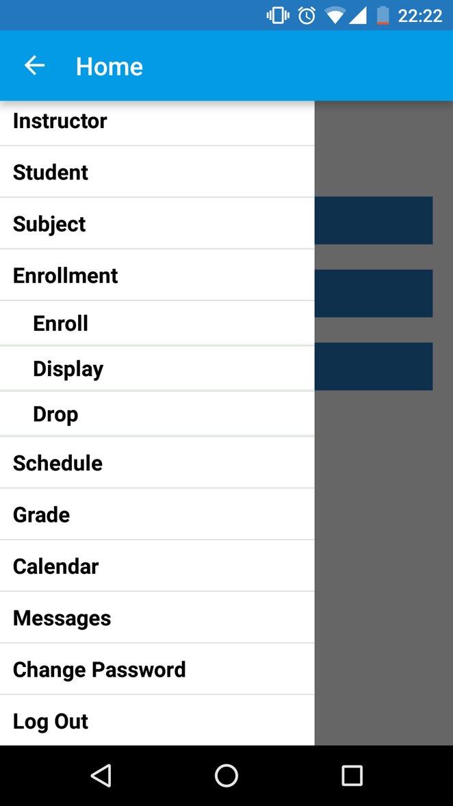

Figure 35. Enrollment options

1. Enroll a student

Upon clicking “Enroll” from the “Sidebar menu”, the admin is redirected to the screen as seen below in Figure 36. From here the admin can select a subject from a dropdown menu. Once the admin selects a subject, there is a list of students that appears in the listview who are not enrolled in the subject. The admin can select multiple students from here and press on the “Enroll” button at the bottom. Upon successful enrollment, the admin will see a confirmation message.

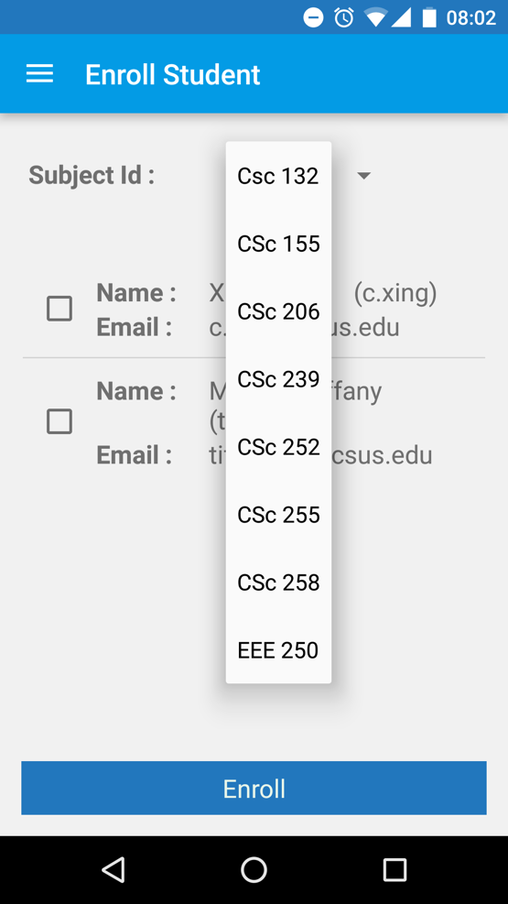 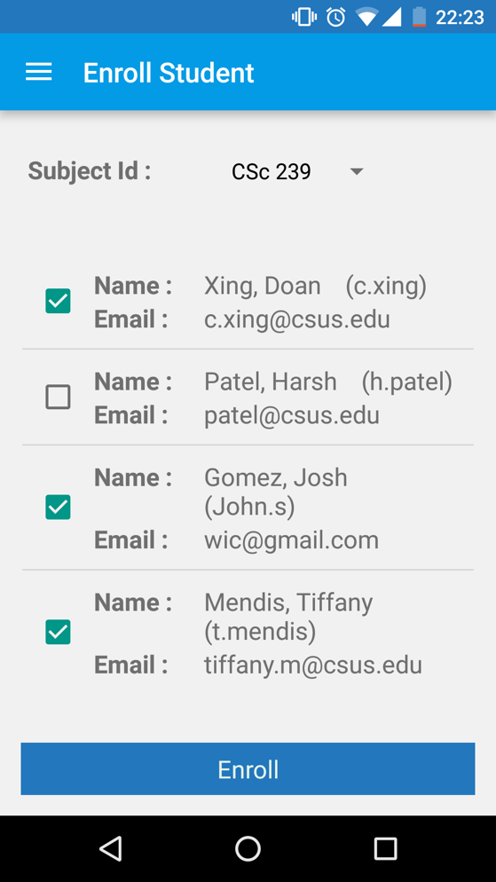

Figure 36. Selecting a subject and Enrolling the students to the subject

Upon clicking “Enroll” tab, the *onCreateView()* method is called from MLAEntollStudentFragment.java. First, it fetches a list of subjects. The *onPostExecute()* method from GetSubjectDetails sub class, then adds all the subjects in the array. The first instance of the array, a subject id, is then passed to another API which is responsible for fetching all the students who are not still enrolled within the subject.

As illustrated below in Figure 37, the code snippet fetches all the subjects with API, @GET("api/Subject/GetAllSubject") with no parameters.

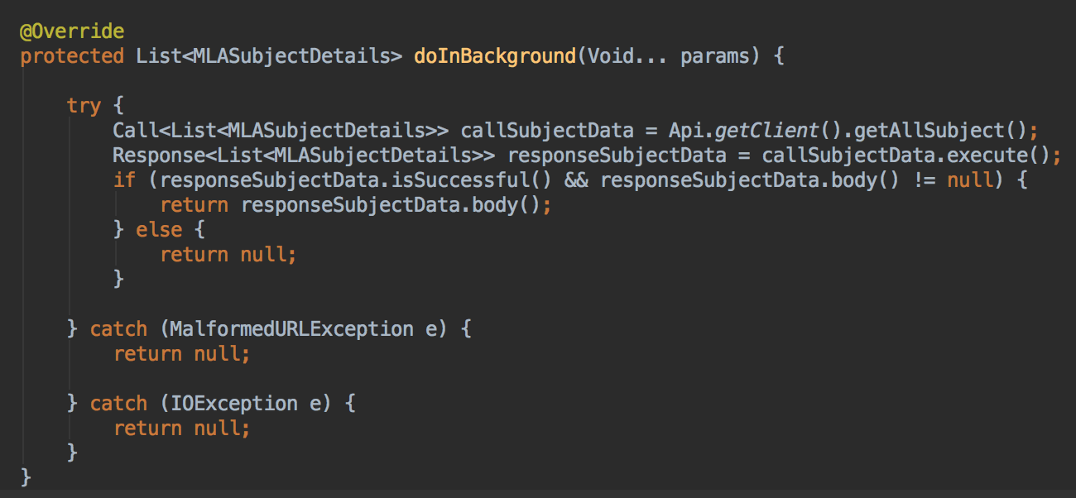

Figure 37. Snippet of fetching a list of subjects from MLAEnrollStudentFragment.java

As illustrated in Figure 38 below, the code snippet fetches all the students who are not yet enrolled within the subject. The API for this is @GET("api/DeEnrollStudent/GetDeEnrollBySubject") with the selected “subject id” from the spinner.

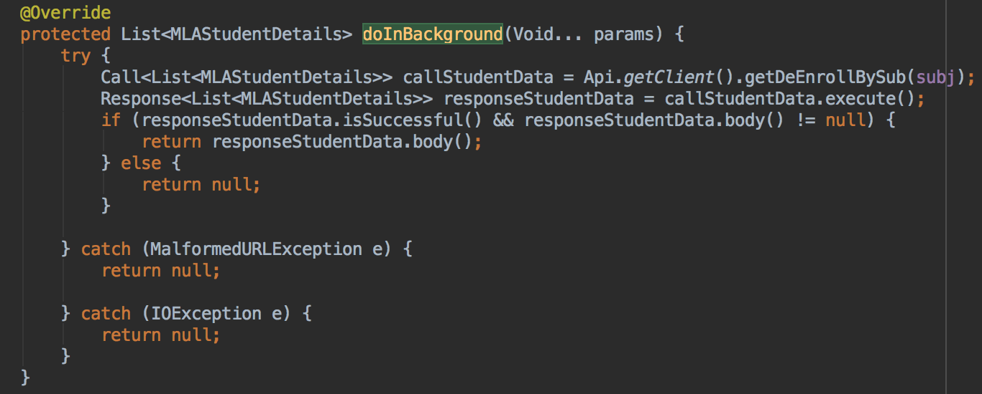

Figure 38. Snippet of fetching a list of students who are not enrolled within the subject from MLAEnrollStudentFragment.java

As illustrated in Figure 39 below, the code snippet enrolls the selected students for the selected subject, @POST("api/EnrollStudent/PostEnrollStudent") with the selected users from the list view and subject id as the parameters.

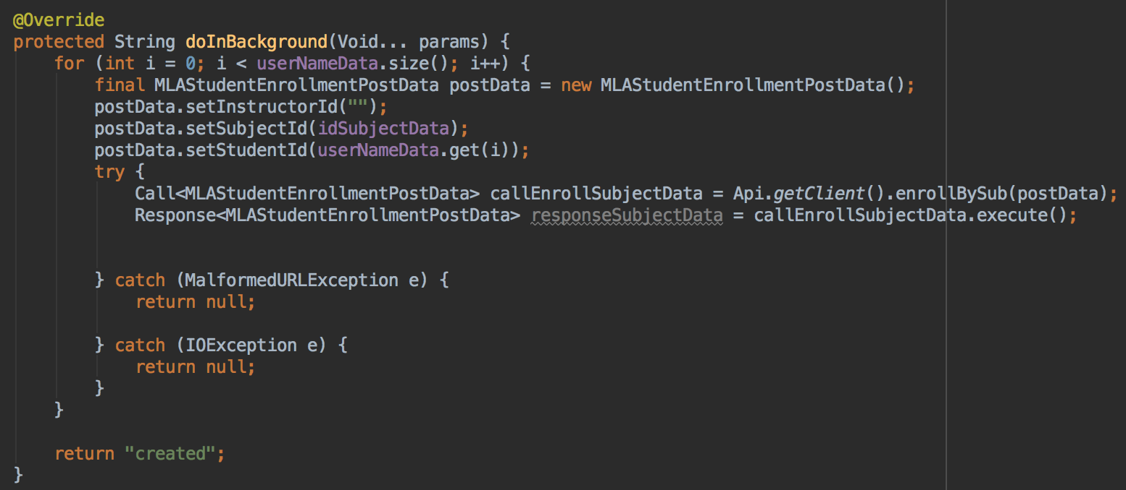

Figure 39. Snippet of enrolling the selected students in the subject from MLAEnrollStudentFragment.java

1. Display enrolled students in the subjects:

For reviewing students under a specific subject, the admin clicks on the “Display” button from the “Sidebar menu”. Here the admin can see a list of subjects in the drop-down menu. When selecting one of the subjects, the admin can see a list of students who are enrolled in that subject in the list view. If a course does not have any students enrolled yet, then the admin will see the message, “No student has been enrolled yet”.

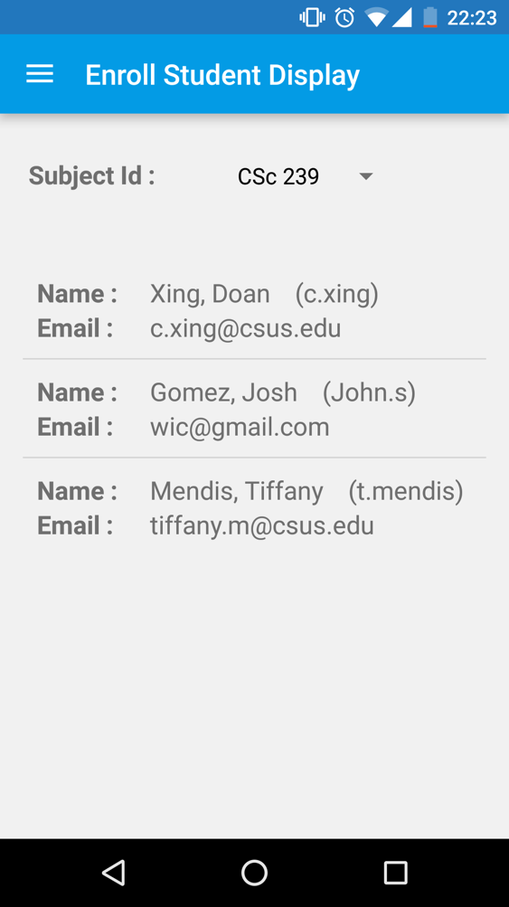

Figure 40. Displaying enrollment of students for the selected subject

For displaying enrolled students for the subject, the same API can be used for fetching all the subjects as well as the list of enrolled students within the subject.

1. Drop currently enrolled students:

When clicking “Drop” from the “Sidebar menu”, the admin is redirected to the screen as seen below in Figure 41. Next, the user will select the subject from which the student is to be removed, and disenroll the student who is currently enrolled in the subject. Upon successful disenrollment, a message will appear on screen. The admin can disenroll multiple students at a time as well.

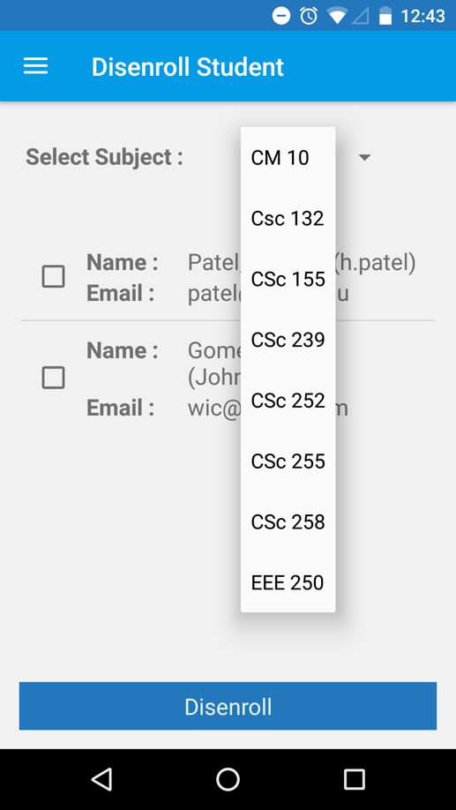 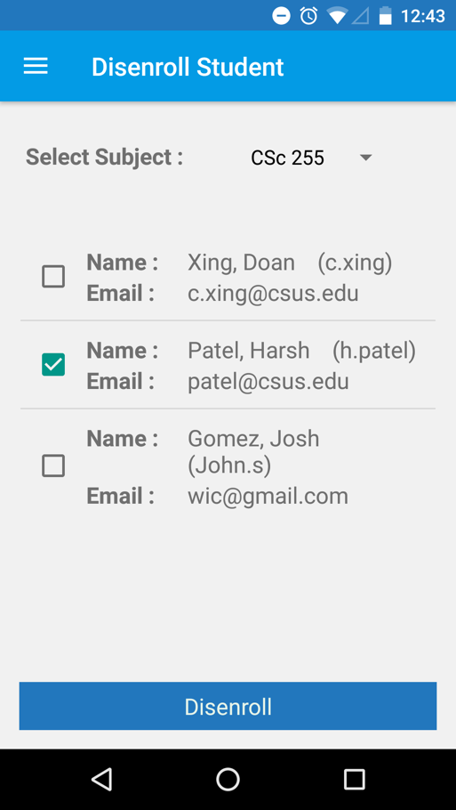

Figure 41. Disenrolling students from the selected subject

Upon clicking “Drop” tab, the *onCreateView()* method is called from MLAStudentDisEnrollFragment.java. First, it fetches a list of subjects. Then, the *onPostExecute()* method from GetSubjectDetails sub class, is added to all the subjects in the array. The first instance of the array, a subject id, is passed to another API which is responsible for fetching all the students who are enrolled within the subject.

As illustrated in Figure 42 below, the code snippet fetches all the subjects with API, @GET("api/Subject/GetAllSubject") with no parameters.



Figure 42 Snippet of fetching a list of all subjects from MLAStudentDisEnrollFragment.java

As illustrated in Figure 43 below, the code snippet fetches all the students who are not yet enrolled within the subject. The API for this is @GET("api/EnrollStudent/GetEnrollBySubject") with the selected “subject id” from the spinner.

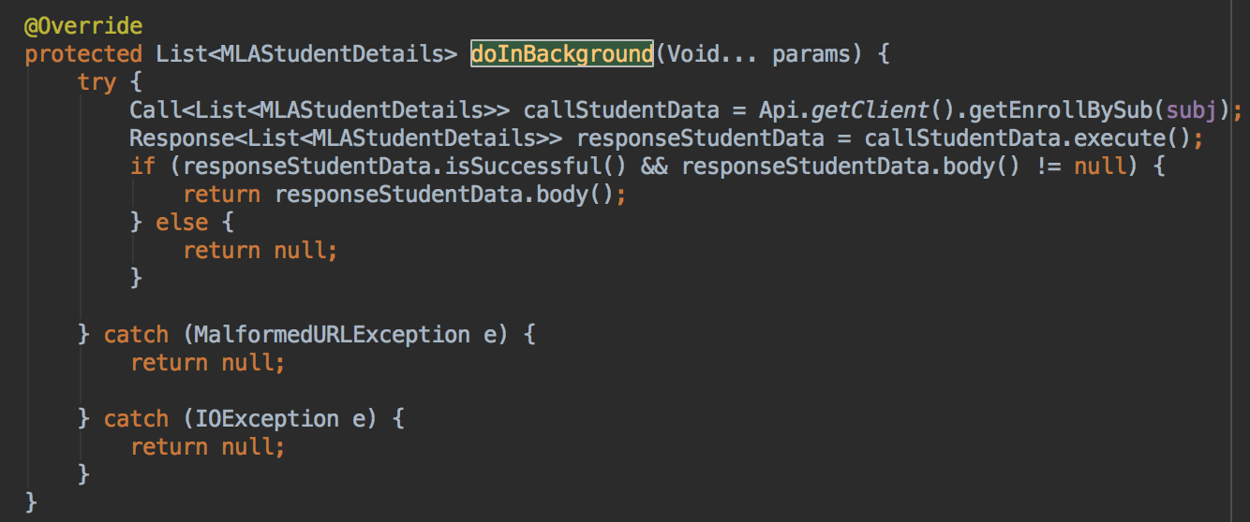

Figure 43. Snippet of fetching a list of all students who are not enrolled within the subject from MLAStudentDisEnrollFragment.java

As illustrated in Figure 44 below, the code snippet disenrolls the selected students for the selected subject, The API is @POST("api/DeEnrollStudent/PostDeEnroll") with the selected users from the list view and subject id as the parameters.

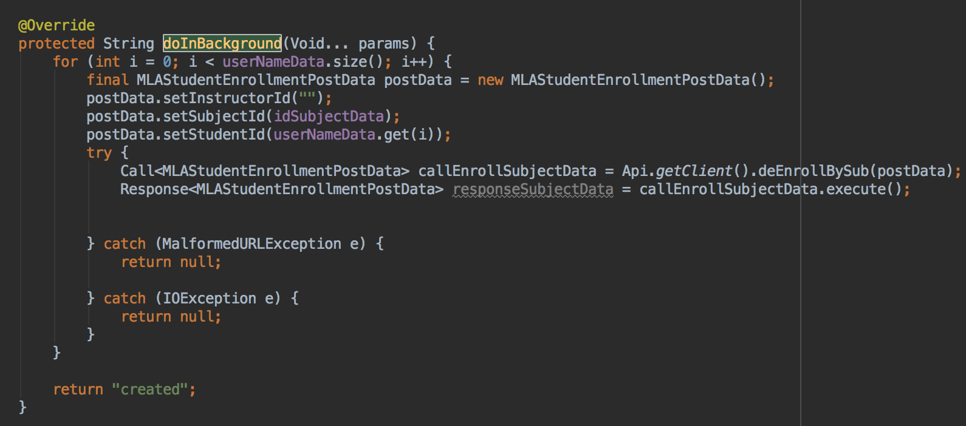

Figure 44. Snippet of enrolling the selected students in the subject from MLAStudentDisEnrollFragment.java

Below are other functionalities that are shown in either the instructor section or the student section:

* Schedule (The workflow is under Instructor)
* Grade (The workflow is under Instructor)
* Calendar
* Messages
* Change password
* Logout

#### **5.1.2.11 Source code summary, functionalities & API for Admin module**

In the following table, there is a list of files along with the brief description of functionalities and API calls they executes. All of the files are developed for an admin module.

|  |  |  |
| --- | --- | --- |
| **Source Code** | **Functionalities** | **API calls** |
| 🡪MLALoginActivity.java | For Login Screen | -/Register/GetRegisterAuth |
| 🡪MLAHomeActivity.java  🡪MLAHomeFragment.java | Displaying a Home Screen | No API call |
| 🡪MLAMyInformationFragment.java | Displaying the admin information | -/Admin/  GetAdminByUserName |
| 🡪MLAAdminViewFragment.java  🡪MLAViewAdminActivity.java  🡪MLAAdminUserDisplayAdapter.java | - Displaying a list of admins  - Adding a new admin  - Editing the information of the admin  - Remove an admin | - /Admin/GetAllAdmin  - /Register/PostAddAdmin  - /Admin/PostAdminUpdate  - /DeleteAdmin/PostAdminRmv |
| 🡪MLAInstructorViewFragment.java  🡪MLAInstructorDisplayAdapter.java  🡪MLAViewInstructorActivity.java | - Displaying a list of instructors  - Adding a new instructor  - Editing the information of the instructor  - Remove an instructor | - /Instructor/GetAllInstructor  - /Register/PostAddInstructor  - /Instructor/  PostInstructorUpdate  -/DeleteInstructor/  PostInstructorRmv |
| 🡪MLAViewStudentActivity.java  🡪MLAStudentDisplayAdapter.java  🡪MLAStudentViewFragment.java | - Displaying a list of students  - Adding a new student  - Editing the information of the student  - Remove a student | - /Student/GetAllStudent  - /Register/PostAddStudent  - /Student/PostStudentUpdate  -/DeleteStudent/  PostStudentRmv |
| 🡪MLAViewSubjectActivity.java  🡪MLASubjectDisplayAdapter.java  🡪MLASubjectViewFragment.java | - Displaying a list of subjects  - Adding a new subject  - Editing the information of the subject  - Remove a subject | - /Subject/GetAllSubject  - /Subject/PostSubject  -/SubjectUpdate/ PostSubjectUpdate  - /SubjectRmv/PostSubjectRmv |
| 🡪MLAEnrollStudentFragment.java  🡪MLAEnrollStudentViewFragment.java  🡪MLAStudentDisEnrollFragment.java  🡪MLAUserViewCheckboxProvider.java  🡪MLAUserDisplayCheckboxAdapter.java | - Displaying Enrollment of the students for a course  - Enrolling the students for a course.  - Disenrolling the students for a course. | - /Subject/GetAllSubject  - /EnrollStudent/  GetEnrollBySubjet  -/EnrollStudent/  PostEnrollStudent  - /DeEnrollStudent/  GetDeEnrollBySubject  - /DeEnrollStudent/  PostDeEnroll |
| 🡪MLATaskViewFragment.java  🡪MLAScheduleAddFragment.java  🡪MLAEditTaskFragment.java  🡪MLAEditTaskDialog.java  🡪MLATasksDeleteFragment.java  🡪MLATaskInProcessViewFragment.java | - Displaying In-Process lectures.  - Displaying a schedule for a course.  - Adding a new schedule for a course.  - Editing a schedule for a course.  - Remove a schedule for a course. | - /Tasks/GetTasksBySubject  - /Subject/GetAllSubject  - /Tasks/PostTask  - /Tasks/PostTaskUpdate  - /ScheduleRmv/PostTaskRmv |
| 🡪 MLAGradeViewFragment.java  🡪 MLAGradeAdapter.java  🡪 MLAUpdateGradeActivity.java | - Displaying a grade of the enrolled students for completed tasks of a course.  - Add a grade for a student.  - Edit a grade for a student | - /Subject/GetAllSubject  - /Tasks/GetStudentByTask  - /Tasks/GetTasksBySubject  - /Tasks/PostGradeUpdate |
| 🡪 MLANewMessageFragment.java | - For sending a new message to the selected user. | - /Admin/GetAllAdmin  - /Instructor/GetAllInstructor  - /Student/GetAllStudent |
| 🡪MLAEditPasswordFragment.java | -For updating the existing password for an admin. | - /Register/  PostRegisterPassUpdate |

Table 4. Code Summary for Admin module

### **Instructor**

#### **Home Screen**

After successfully logging in as an Instructor, the instructor can see a Home screen with a list of subjects that are assigned to him or her.

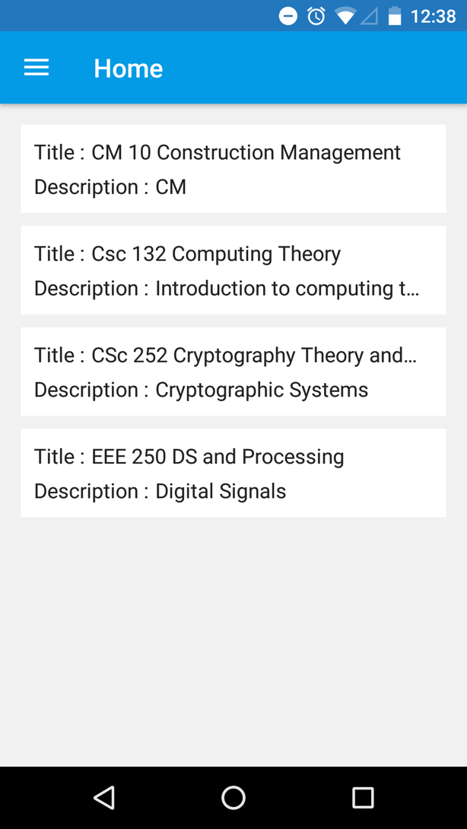

Figure 45. Instructor Home Screen

On this screen, the logged-in instructor can see a list of subjects which are assigned to the instructor. There is no API for this, so a code fetches all the subjects, and as shown in Figure 46 below, the filter will occur at the Front-End side.

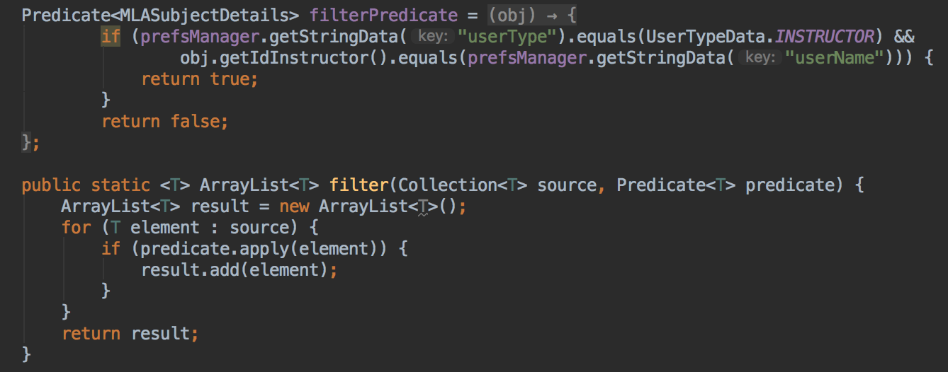

Figure 46. Snippet of filtering subjects which are assigned to the logged-in instructor from MLAAssignedSubjectViewFragment.java

#### **Privileges**

Compared to an admin, an instructor can’t add, edit, or remove other admins, other instructors, students, and subjects; however, an instructor can add, edit or remove schedules and grades for the courses which are assigned to him.

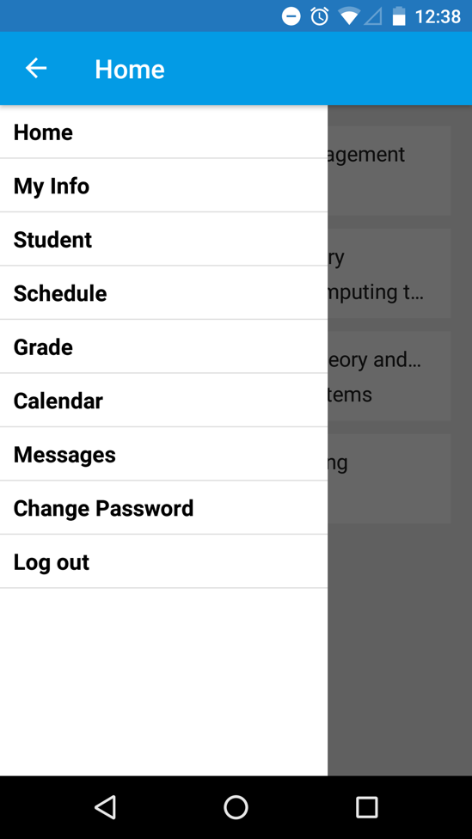

Figure 47. Privileges of instructor

#### **View Students**

From the sidebar menu, go to the Students tab. The instructor can see a list of all the students who are enrolled in a specific subject that he/she teaches. As shown in Figure 48, the instructor can see a list of students by selecting a subject from the dropdown menu.

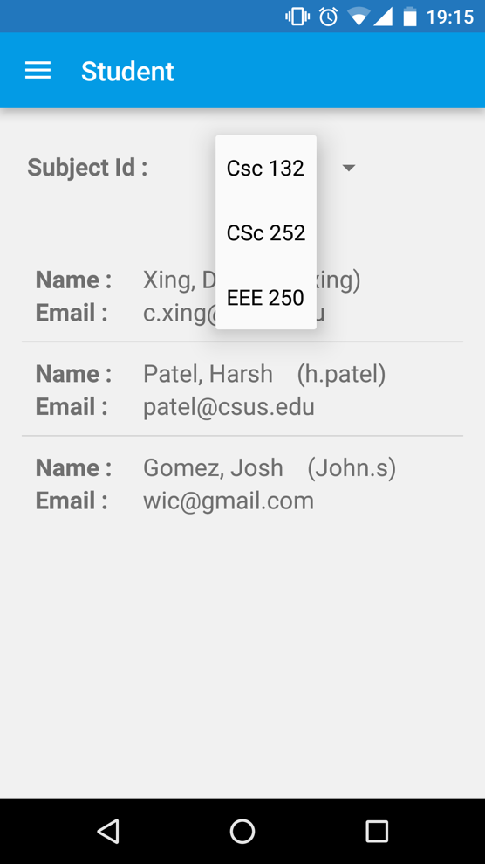 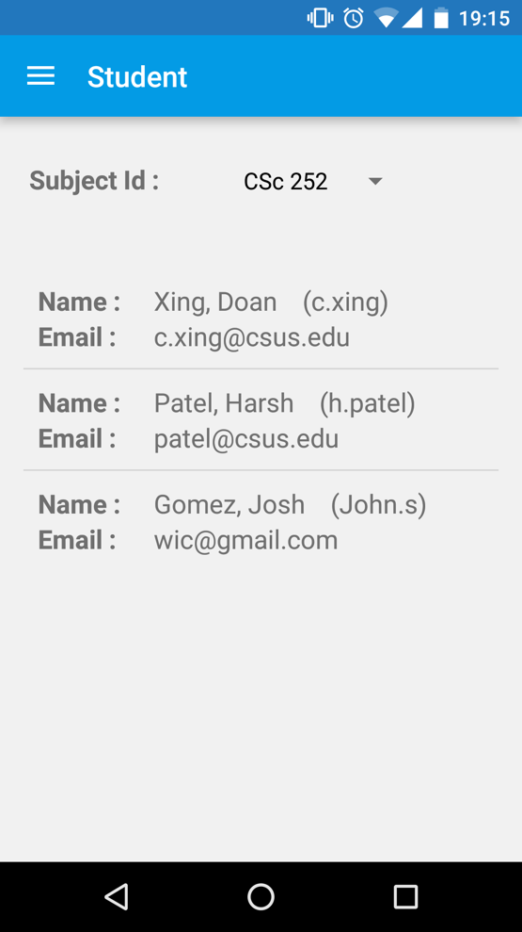

Figure 48. A list of students for the selected subject

#### **Schedule**

An admin and an instructor can add, edit, or remove a schedule for a specific subject. As shown in Figure 49, from the sidebar menu an instructor can select from the given options: 1.) In-Process, 2.) Add Schedule, 3.) Display Schedule, 4.) Edit Schedule, and 5.) Remove Schedule.

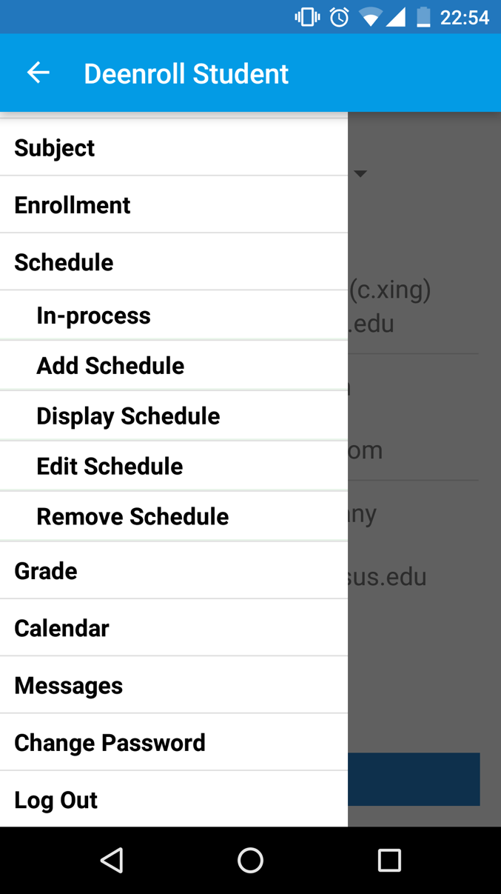

Figure 49. Different options of Schedule module

1. How to view current schedule

Select the “Add Schedule” tab as shown in Figure 50. From here, an instructor can select a list of all the subjects for which the schedules are not added and which are assigned to him or her. As shown in Figure 50, the instructor must fill the appropriate fields. After getting a successful response from a server, a message box appears with options that ask to add tasks “ADD NOW” and “LATER”. If the user would like to add the tasks later then the user will be redirected to Home screen. If the user wants to add now then the user will be navigated to Edit Schedule Screen.

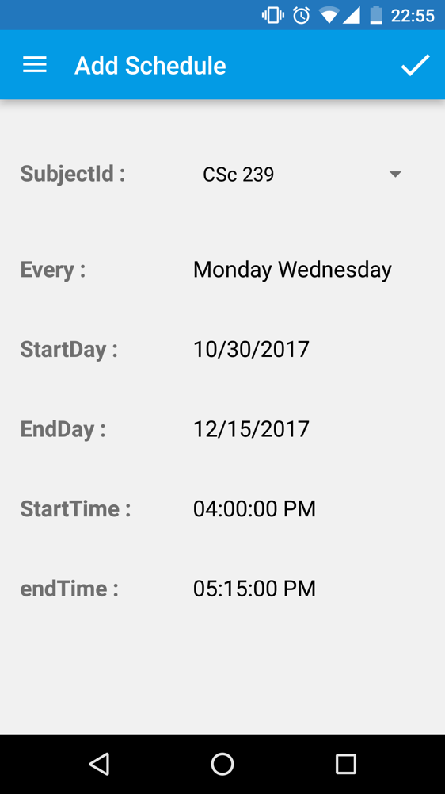 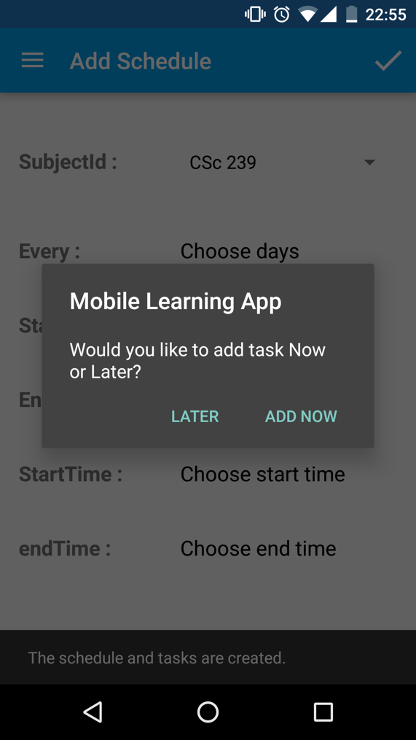

Figure 50. Adding a schedule for the subject

As shown in Figure 51 below, the API, @GET("api/Subject/GetAllSubjectWithTask"), with False parameter fetches all the subjects for which the schedule has not been added.

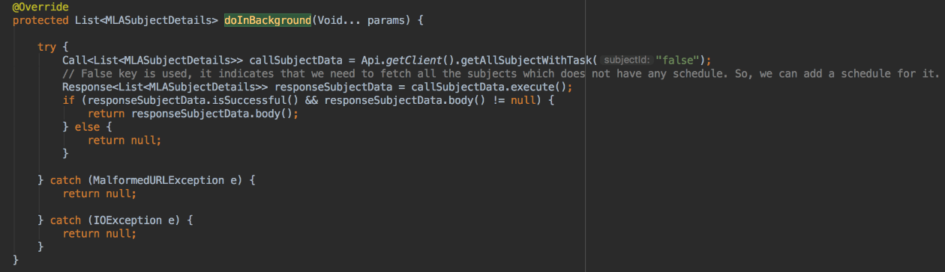

Figure 51. Snippet of filtering subjects for which the tasks are not assigned yet from MLAScheduleAddFragment.java

Then the instructor adds all the required parameters, Start Date, End Date, Start Time, End Time, and Selection of Days. Once the instructor presses the “✓”, the MLAScheduleAddFragment.java has a code for adding a schedule for the selected subject. The API, @POST("api/Tasks/PostTask/"), adds a schedule for the subject.

1. How to edit a schedule

Select “Edit Schedule” under “Schedule” in the left pane, as illustrated in Figure 52 below, to view and to edit the schedule for an entire semester. From here the instructor or the admin can see a list of all the tasks of an entire semester. The user can edit a topic name and description of a task which is going to be studied in the lecture.

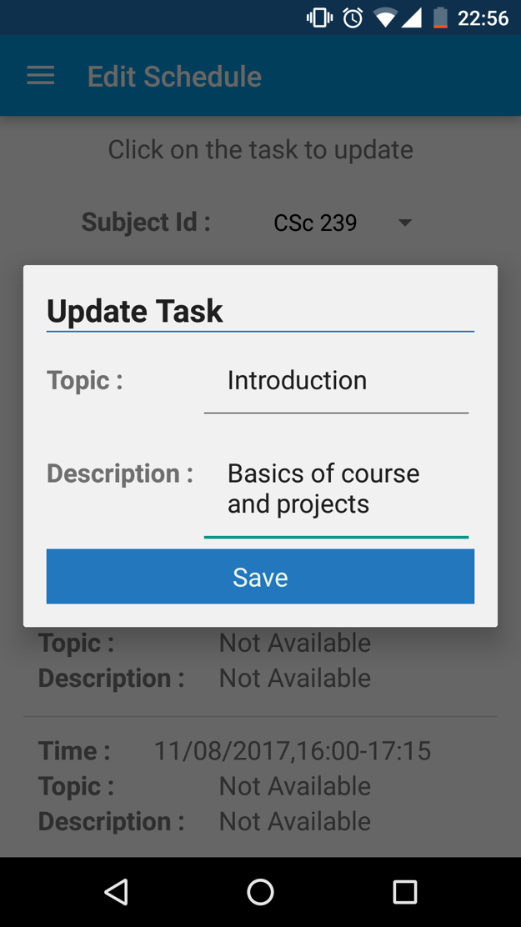 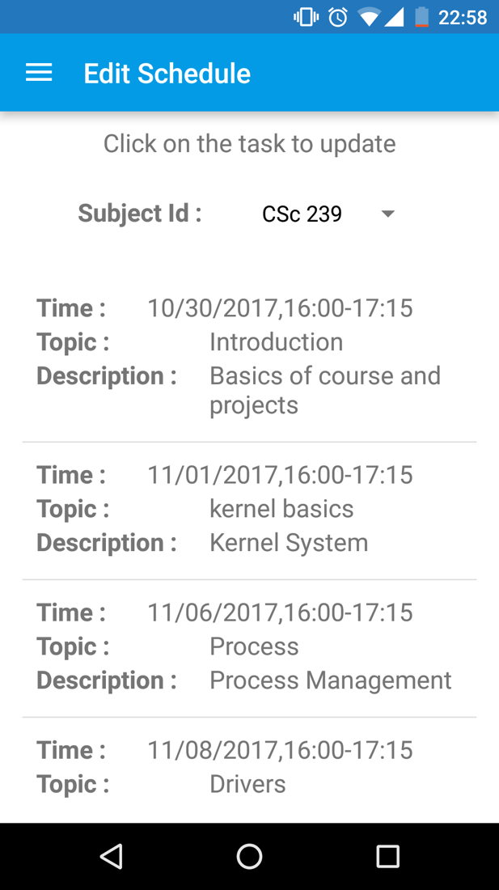

Figure 52. Editing an information of the scheduled task

The flow for editing a schedule from the file, MLAEditTaskFragment.java, is as below,

1. Fetch all the subjects with GetAllSubjects API.
2. The filtered subjects for the logged-in instructor, the screen should show a list of subjects which are assigned the logged-in instructor.
3. Upon selecting a subject from Spinner, the associated tasks to the subject will be fetched.
4. On selecting an item, a dialog box will be opened. The implementation file is MLAEditTaskDialog.java, which updates the task upon pressing “Save.”

Figure 53 shows a second step from the mentioned flow. The API, @GET("api/Tasks/GetTasksBySubject"), is called with subject id as a parameter.

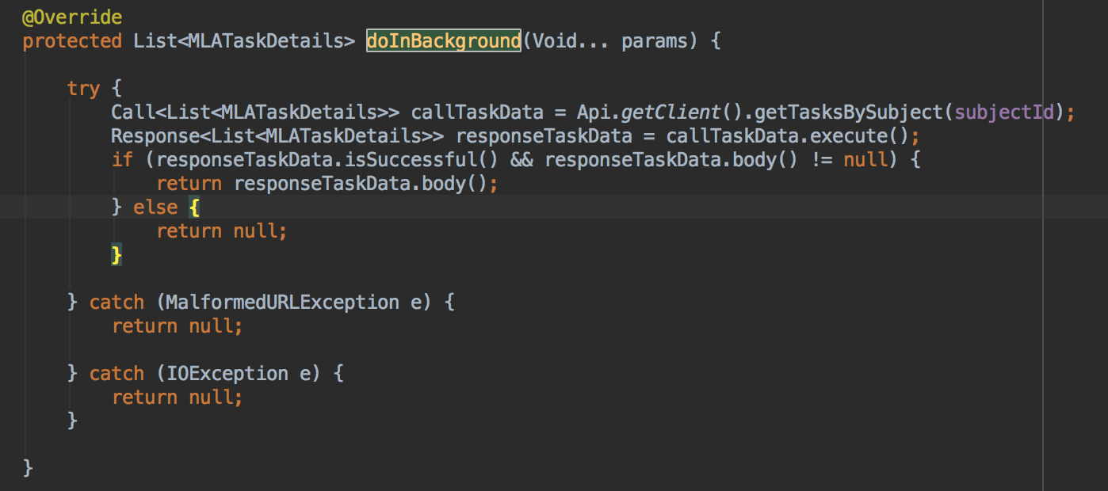

Figure 53. Snippet of fetching all the associated tasks for the selected course from MLAEditTaskFragment.java

As shown in Figure 54 below, when the instructor selects on a task for editing, it redirects to the MLAEditTaskDialog.java.

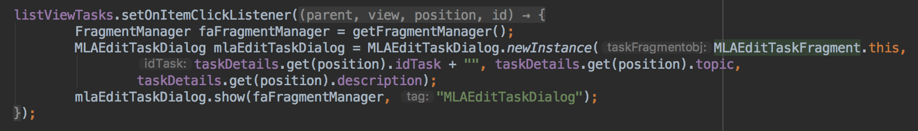

Figure 54. Snippet of selecting a task from the associated tasks from MLAEditTaskFragment.java

As illustrated in Figure 55 below, the API, @POST("api/Tasks/PostTaskUpdate"), is called for updating the task.

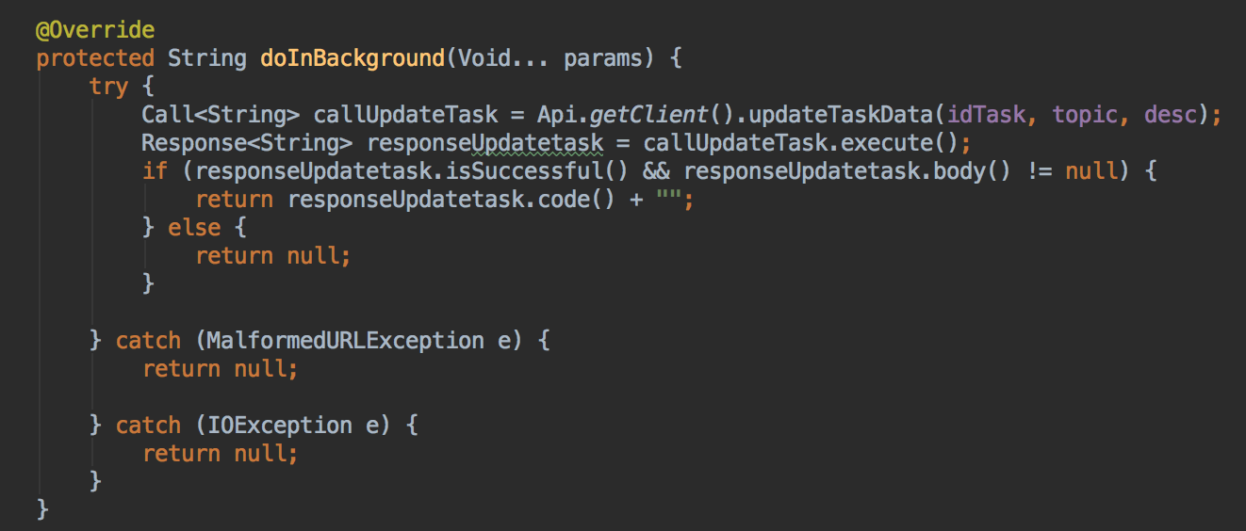

Figure 55. Snippet of calling an API for submitting the edited task from MLAEditTaskDialog.java

1. How to view entire schedule

Select “Display Schedule” under “Schedule” in the left pane, as shown in Figure 56, to view entire semester’s schedule. From here the instructor or the admin can see a list of all the tasks of an entire semester.

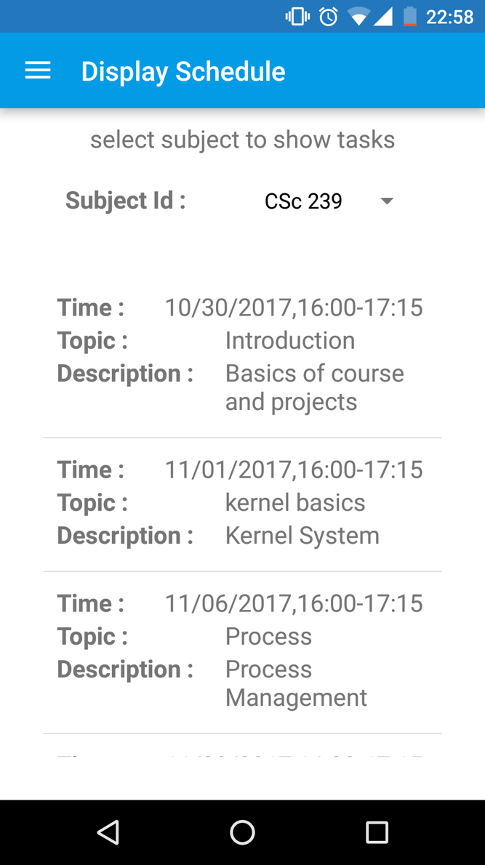

Figure 56. Displaying the scheduled tasks

1. How to remove a schedule

Select the “Remove Schedule” tab under “Schedule” in the left pane, as shown in Figure 57, to view the entire semester’s schedule. From here the instructor or the admin can see a list of all the courses, which has a list of tasks. Select a subject to remove an entire schedule of the subject.

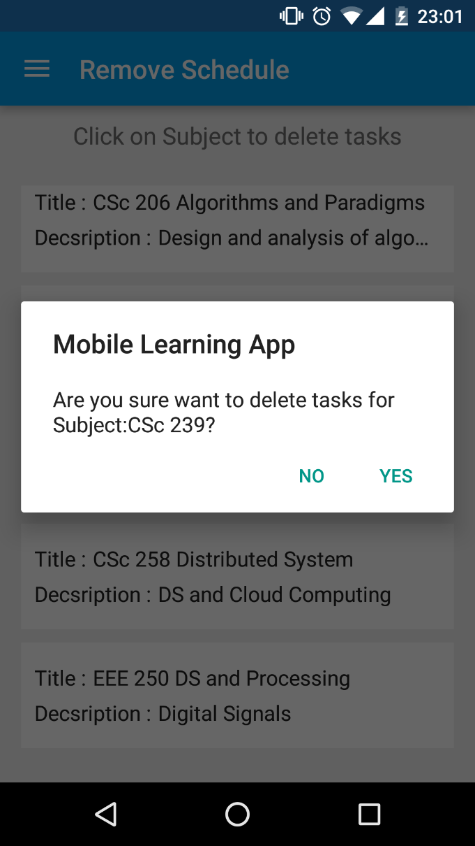

Figure 57. Removing a schedule for the selected subject

The flow for removing schedule from the file, MLATasksDeleteFragment.java, is as below,

1. Fetch all the subjects for which the tasks are added with API, @GET("api/Subject/GetAllSubjectWithTask"), along with true flag as parameter.
2. The filtered subjects for the logged-in instructor, the screen should show a list of subjects which are assigned the logged-in instructor.
3. Upon selecting a subject, the associated tasks to the subject will be removed.

As shown in Figure 58 below, the code snippet asks for the confirmation to the logged-in instructor for deleting the tasks.

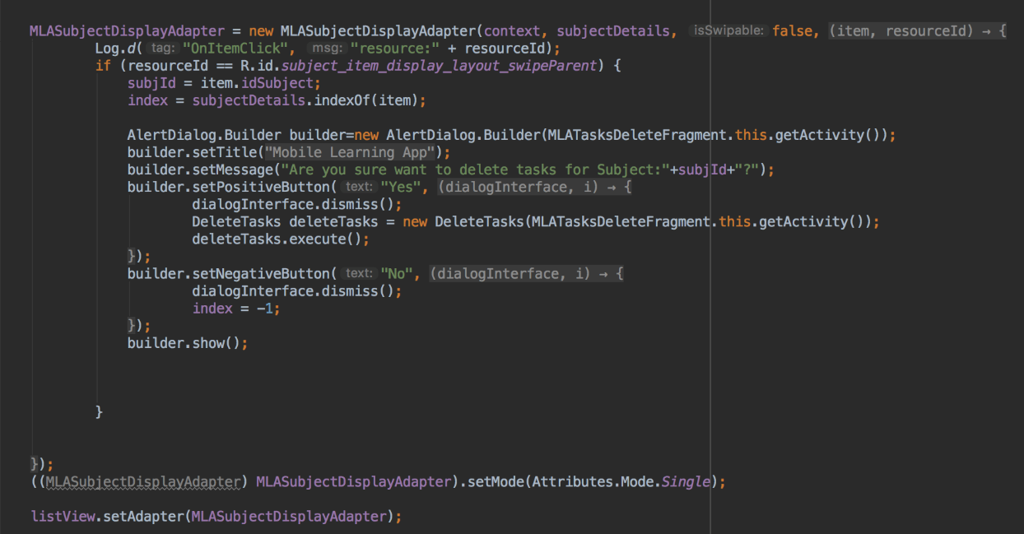

Figure 58. Snippet of selecting a subject for removing the tasks from MLASubjectDisplayAdapter.java

As shown in Figure 59 below, the code snippet calls an API, @POST("api/ScheduleRmv/PostTaskRmv"), for removing the tasks for the selected subject.

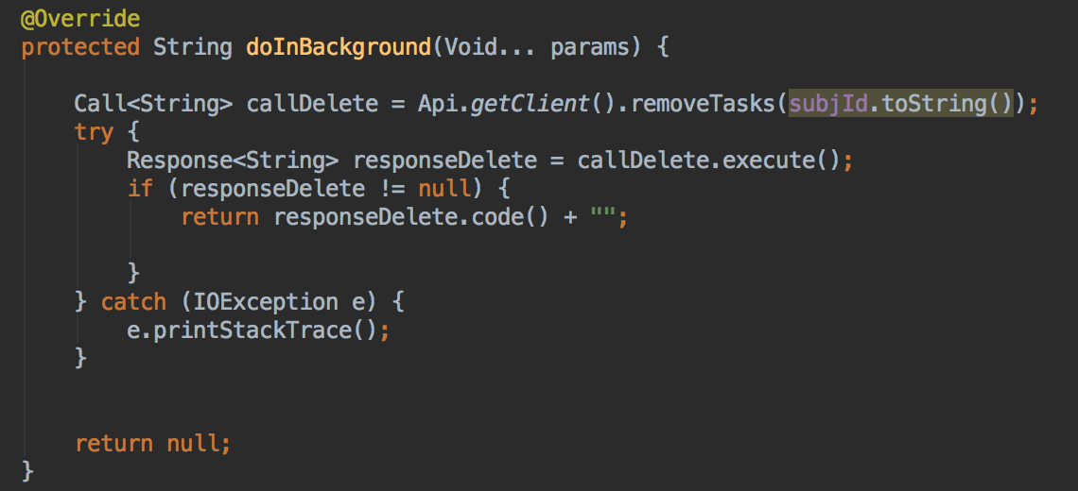

Figure 59. Snippet of calling an API for removing the tasks for the subject from MLASubjectDisplayAdapter.java

1. In-Process schedule

Select the “In-process Schedule” tab under “Schedule” in the left pane, as shown in Figure 60, to view the currently ongoing subject. From here the instructor can see a list of subjects. As shown in the figure, for EEE 250 there is a lecture in progress, but for CSC 132, there is no lecture in progress.

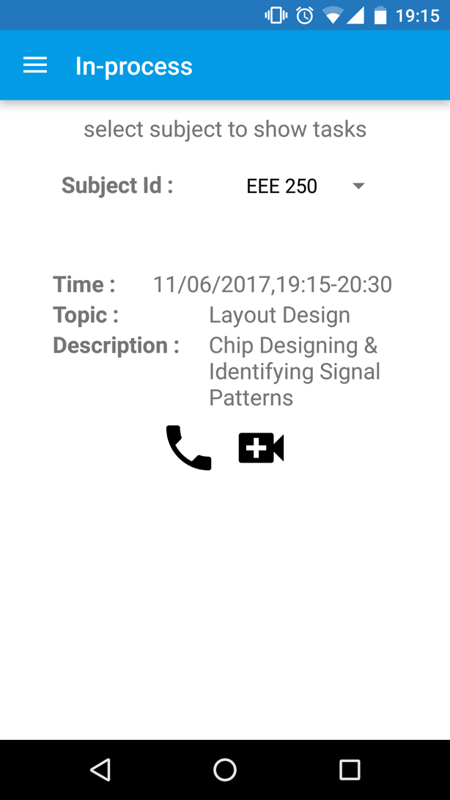 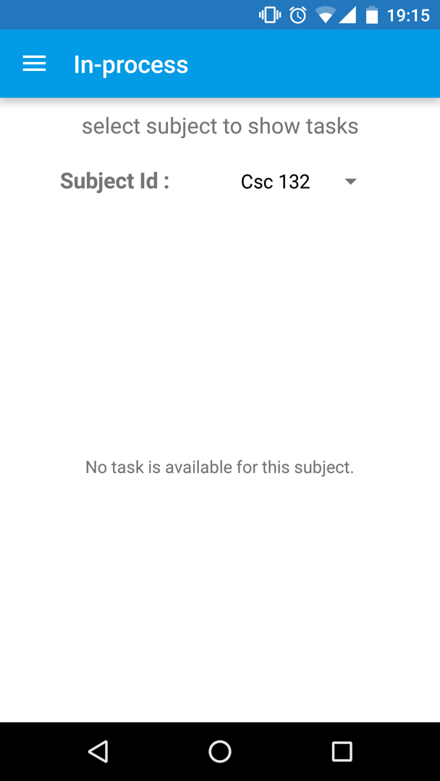

Figure 60. In-Process schedule

If the instructor would like to connect with a student who is enrolled in the class, the instructor can select either “Audio Call” or “Video Call.” After selecting one of the options, the instructor can see a list of the students who are enrolled within a subject. By selecting one of them, the instructor can make an Audio Call / Video Call to a specific student.

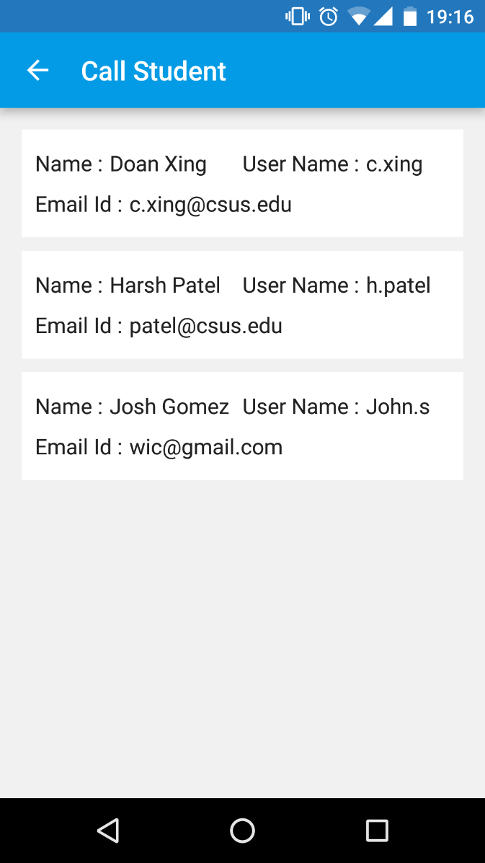

Figure 61. A list of the enrolled students

So once the instructor selects one of the students from a list, he will be redirected to the Place Call screen, where the Sinch [18] username of a student will appear automatically. Sinch is a third-party library for making an Audio and Video calling. Here the application asks the instructor to grant access to a microphone and camera for the first time. Once the instructor grants access, then the instructor can make the call to the student.

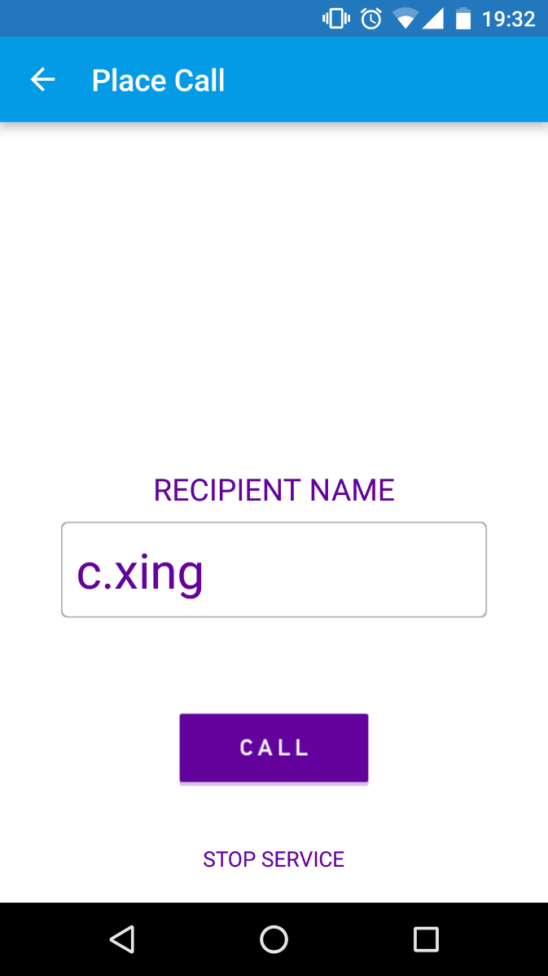

Figure 62. Sinch Calling to the student

Below is an example of Audio call and Video call from the application. It is an app-to-app calling feature.

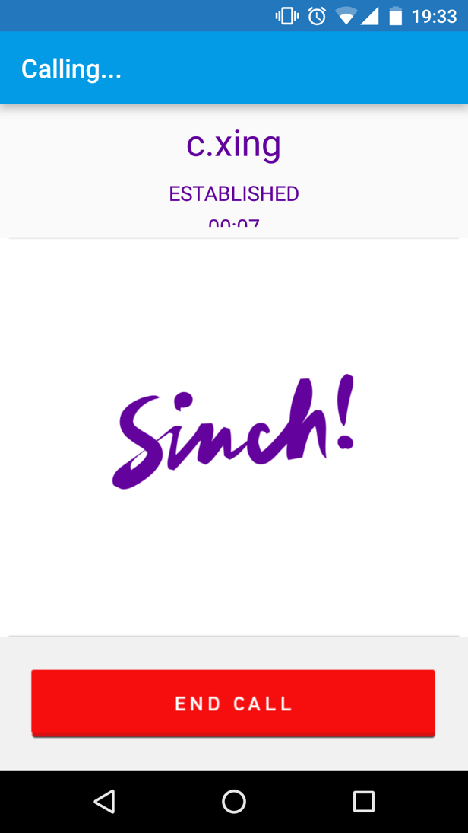

Figure 63. Sinch Audio Calling

The flow for In-Process schedule from the file, MLATaskInProcessViewFragment.java, is as below,

1. Fetch all the subjects with GetAllSubjectAPI.
2. The filtered subjects for the logged-in instructor, the spinner should show a list of subjects which are assigned the logged-in instructor.
3. Upon selecting a subject from the spinner, a list of tasks will be fetched from the API. Then the associated Start Time and End Time will be compared with the System Time. If the different times match, then the task will be shown as in-process.
4. When selecting the “Audio Call” or “Video Call” buttons, the instructor will be navigated to the CallStudentActivity.java file.
5. From here, the list of students will be fetched using @GET("api/EnrollStudent/GetEnrollBySubject") API.
6. Upon selecting a student, the instructor will be connected to the student.

As shown in Figure 64 below, the code snippet checks whether the tasks for the selected subject is in process or not by matching the Start Time with the System Time.

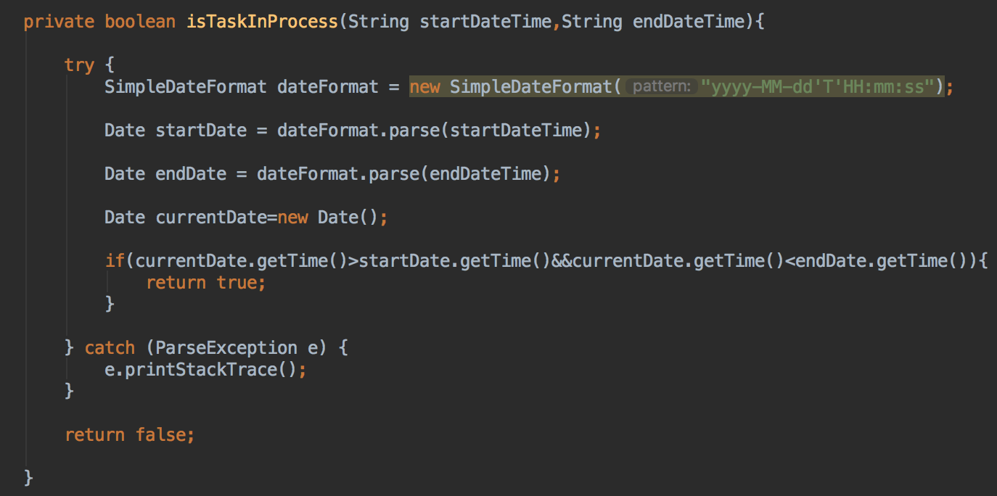

Figure 64. Snippet for checking whether the task is in process or not from MLATaskInProcessViewFragment.java

As shown in Figure 65, the code snippet redirects the user to the CallStudentActivity.java file, where the instructor can see a list of the students who are enrolled for the subject.

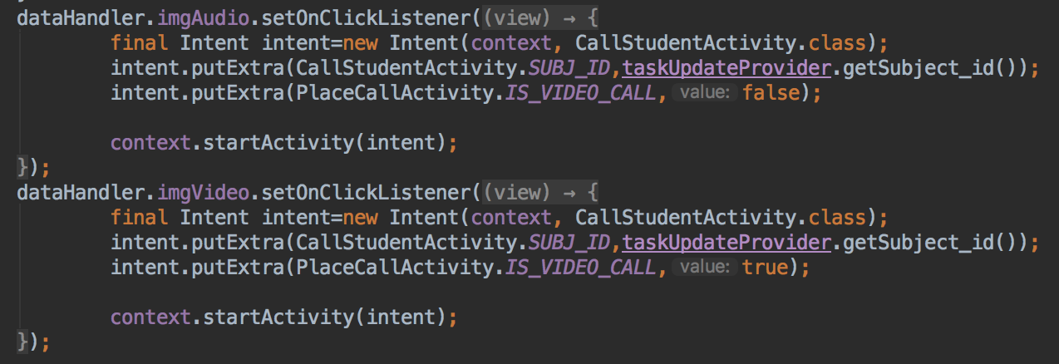

Figure 65. Snippet for selecting either “Audio Call” or “Video Call” from MLATaskUpdateAdapter.java

As shown in Figure 66 below, the code snippet redirects the user to PlaceCallActivity.java file, the file is responsible for handling either “Audio Call” or “Video Call” which depends on the selection of the instructor.

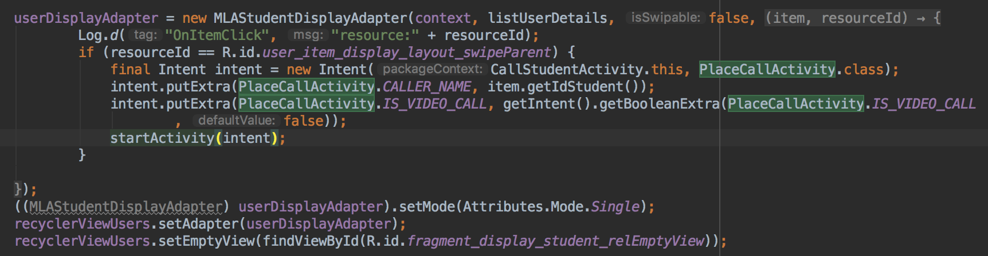

Figure 66. Snippet of calling either “Audio call” or “Video Call” from CallStudentActivity.java

#### **Add Grade**

An instructor or an admin can assign and edit a grade for the students for a subject. To add or modify the grade of the students, the user must go to the “Grade” tab from the “Sidebar Menu”.

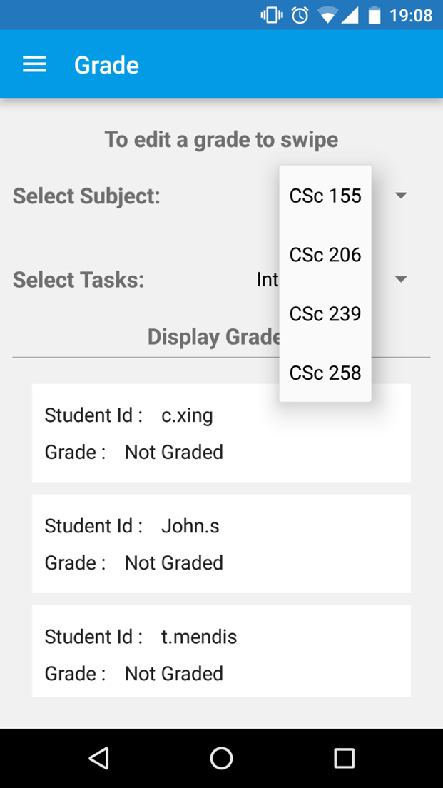 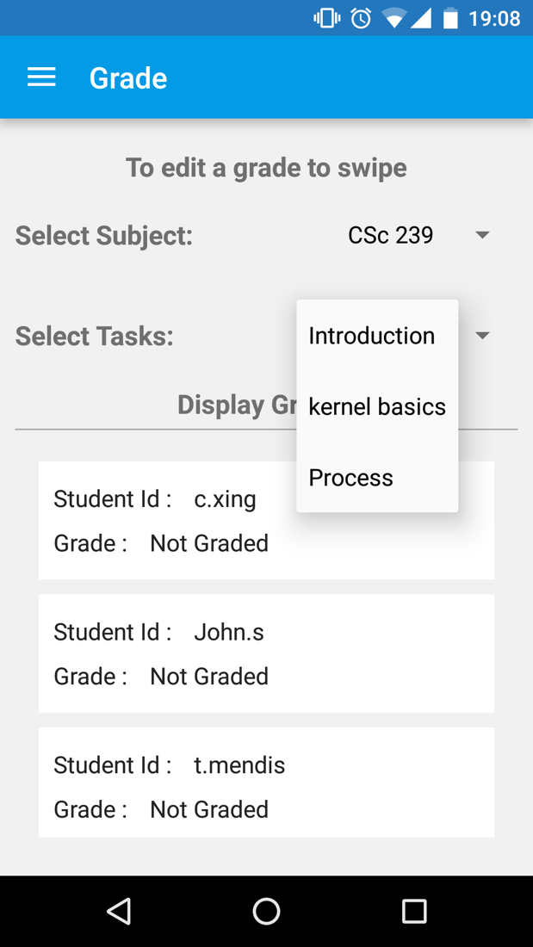

Figure 67. Displaying grades of the enrolled students

To edit a grade for a student, do a left swipe on student row. The instructor/the admin will be redirected to the screen assigning a grade. From here the user can select a grade and select “✓”. Below is the sequence which shows how to assign/modify a grade for a student.

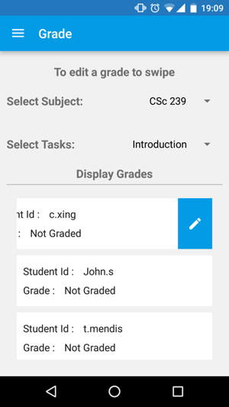 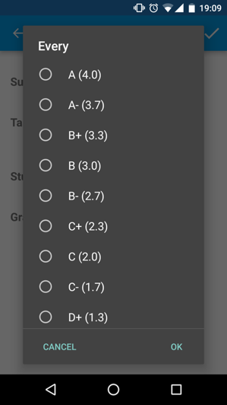 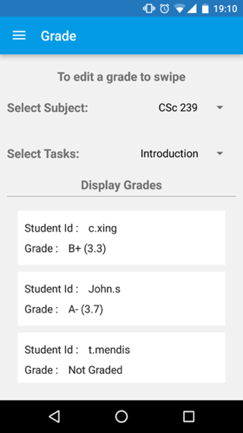

Figure 68. Editing a grade of the student

The flow for Adding Grades from the file, MLAGradeViewFragment.java, is as below,

1. Fetch all the subjects with GetAllSubjectAPI.
2. The filtered subjects for the logged-in instructor, the spinner should show a list of subjects which are assigned the logged in instructor.
3. Upon selecting a subject from the spinner, a list of tasks will be fetched from the API. Those tasks will be added to another spinner.
4. On selecting either of them, the grades will be displayed for the enrolled students using API, @GET("api/Tasks/GetStudentByTask").
5. To edit a grade for the selected task and for the selected student, left swipe on the respective row.
6. The instructor will then be navigated to the MLAGradeViewFragment.java to MLAUpdateGradeActivity.java file. Here the instructor can update the grade using the predefined grades using @POST("api/Tasks/PostGradeUpdate") API.

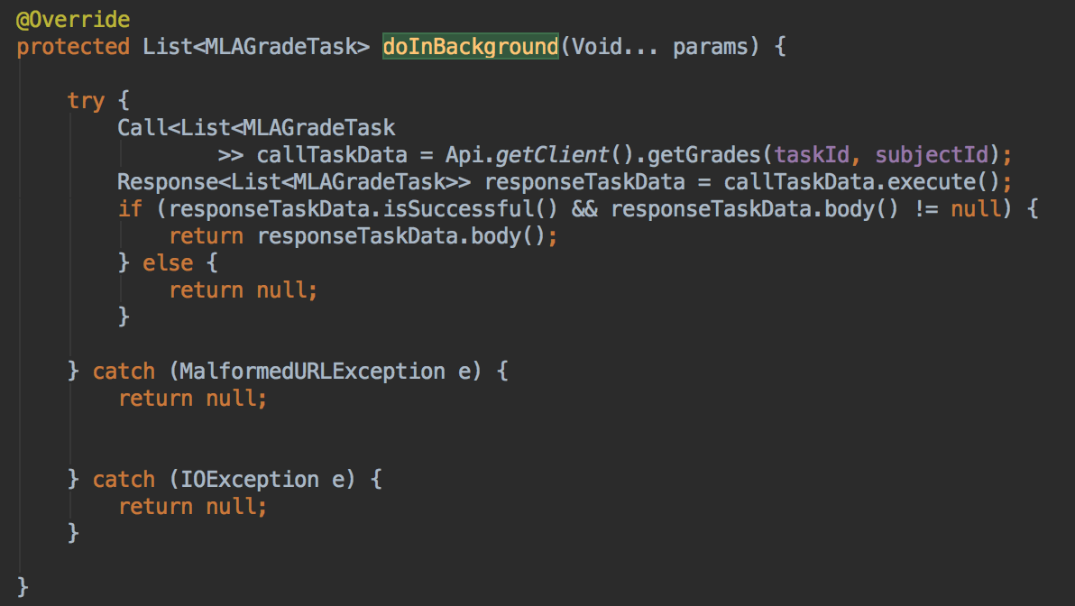

Figure 69. Snippet for calling an API to fetch the grades for the enrolled students from MLAGradeViewFragment.java

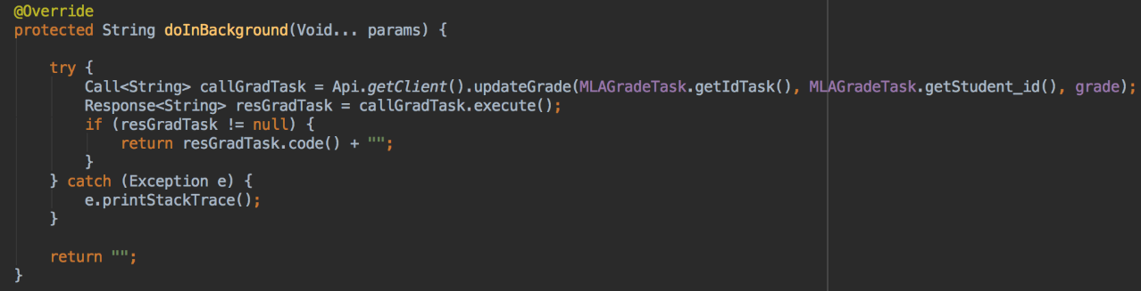

Figure 70. Snippet for calling an API to update the grades for the enrolled student from MLAUpdateGradeActivity.java

#### **Calendar**

After assigning a new schedule, the schedule will be saved in the Google Calendar of the instructor or the admin. To view the Google calendar, it can be selected from the “Sidebar Menu” or through the “Hamburger Menu”, which selects the calendar.

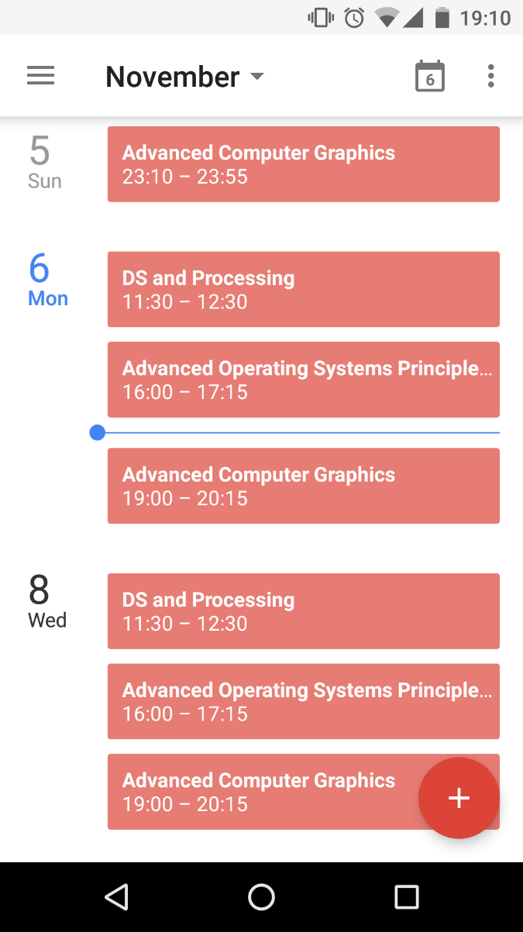

Figure 71. Class schedules in Google Calendar

#### **Source code summary, functionalities & API for Instructor module**

In the following table, there is a list of files along with the brief description of functionalities and API calls they executes. All of the files are developed for an instructor module.

|  |  |  |
| --- | --- | --- |
| **Source Code** | **Functionalities** | **API calls** |
| 🡪MLALoginActivity.java | For Login Screen | - /Register/GetRegisterAuth |
| 🡪MLAHomeActivity.java  🡪MLAAssignedSubjectViewFragment.java.java | Displaying a list of subjects which are taught by an instructor | -/Subject/GetAllSubject |
| 🡪MLAMyInformationFragment.java | Displaying the admin information | -/Admin/  GetAdminByUserName |
| 🡪MLAInstructStudentViewFragment.java | - Displaying a list of students who enrolled within a course | - /Subject/GetAllSubject  -/EnrollStudent/  GetEnrollBySubject |
| 🡪MLATaskViewFragment.java  🡪MLAScheduleAddFragment.java  🡪MLAEditTaskFragment.java  🡪MLAEditTaskDialog.java  🡪MLATasksDeleteFragment.java  🡪MLATaskInProcessViewFragment.java  🡪CallStudentActivity.java  🡪PlaceCallActivitiy.java  🡪AudioPlayer.java  🡪CallScreenActivity.java  🡪IncomingCallScreenActivity.java  🡪LoginActivity.java  🡪SinchService.java  🡪VideoCallScreenActivity.java | - Displaying In-Process lectures.  - Displaying a schedule for a course.  - Adding a new schedule for a course.  - Editing a schedule for a course.  - Remove a schedule for a course.  - Place an Audio call or Video call between Instructor and Student | - /Tasks/GetTasksBySubject  - /Subject/GetAllSubject  - /Tasks/PostTask  - /Tasks/PostTaskUpdate  - /ScheduleRmv/PostTaskRmv |
| 🡪MLAGradeViewFragment.java  🡪MLAGradeAdapter.java  🡪MLAUpdateGradeActivity.java | - Displaying a grade of the enrolled students for completed tasks of a course.  - Add a grade for a student.  - Edit a grade for a student | - /Subject/GetAllSubject  - /Tasks/  GetStudentByTask  -/Tasks/  GetTasksBySubject  - /Tasks/PostGradeUpdate |
| 🡪MLANewMessageFragment.java | - For sending a new message to the selected user. | - /Admin/GetAllAdmin  - /Instructor/GetAllInstructor  - /Student/GetAllStudent |
| 🡪MLAEditPasswordFragment.java | -For updating the existing password for an admin. | - /Register/  PostRegisterPassUpdate |

Table 5. Code Summary for Instructor module

### **Students**

#### **Home Screen**

After doing successful login as a Student, the student can see the Home screen with a list of subjects in which he or she is enrolled.

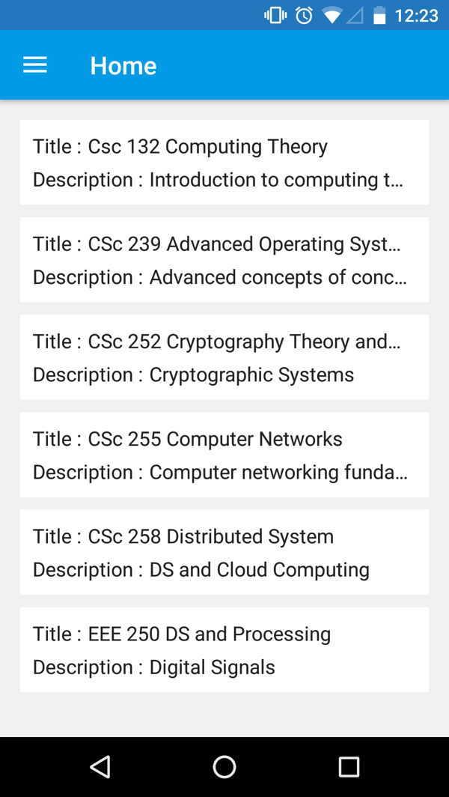

Figure 72. Home screen of Student module

After successfully logging in as a Student, the student will be navigated to the MLAStudentSubjectViewFragment.java file. Here the API, @GET("api/Subject/GetSubjectByStudent"), is called to fetch all the subjects in which the logged-in student is enrolled.

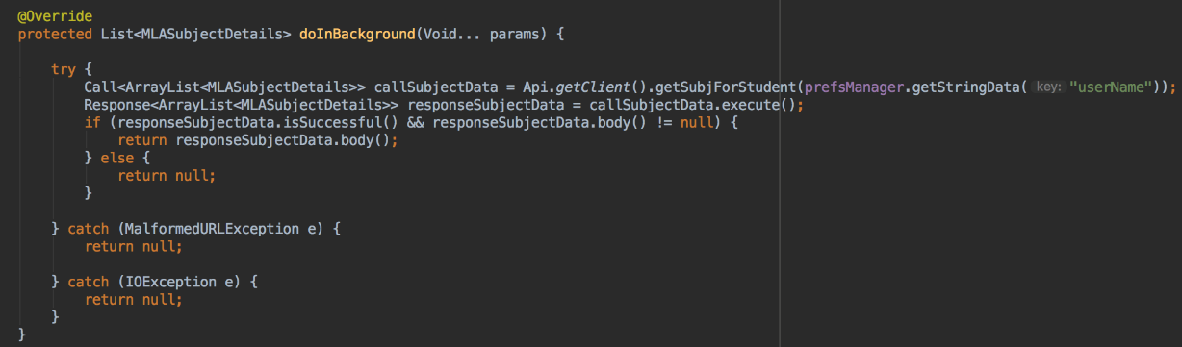

Figure 73. Snippet for calling an API for fetching list of subjects for the logged in student from MLAStudentSubjectViewFragment.java

#### **Privileges**

After successfully logging in as a Student, unlike an admin and an instructor, the students can see only grades and the schedule for their enrolled subjects.

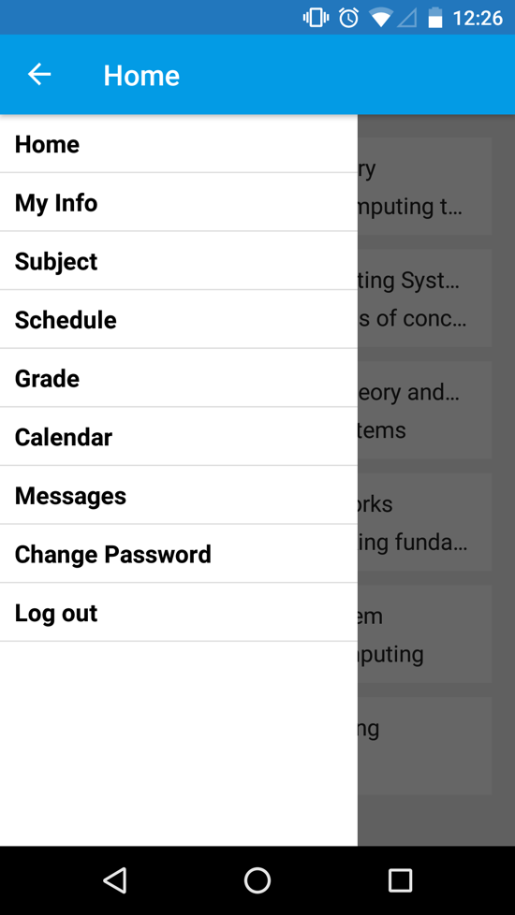

Figure 74. Privileges for student user type

#### **In-Process Schedule**

Upon clicking on the In-Process schedule, a student can see a list of their currently enrolled subjects. From here the user can see currently on-going tasks/sessions of the subject, if any. Here the student can see 4 buttons, a progress bar and detail of the session. The “Start” button is used as a timer for the student. When the student presses the “Start” button, the application matches the system time of the Android device with the duration of lecture, and with that basis the progress can be seen with the progress bar. The yellow bar of the session shows the ongoing progress the student is making within the course. Every 3 seconds, the application checks the status of the buttons and accordingly updates the progress bar. If the pause button is pressed, then it pauses progress.

For example, as shown in Figure 75, EEE 250 has an ongoing session which is from 19:15 to 20:30. So the total length of the lecture is 75 minutes. The user starts the progress by pressing the “Start” button. The application shows 66.66% progress after 50 minutes which is by 20:05. Meanwhile, if the student would like to pause their progress, they can click on the “Pause” button. During this time, the application will not update the progress bar. To see progress again, the student needs to press the “Start” button again. To connect with the instructor of the course, there are 2 options: 1.) Audio Call, and 2.) Video Call. Depending on their needs, the student can select one of these options to connect with the instructor. This feature provides an efficient way of communication between instructors and students. As shown in Figure 75, the student connects with the instructor, John.i (Sinch Username), by placing an audio call or a video call.

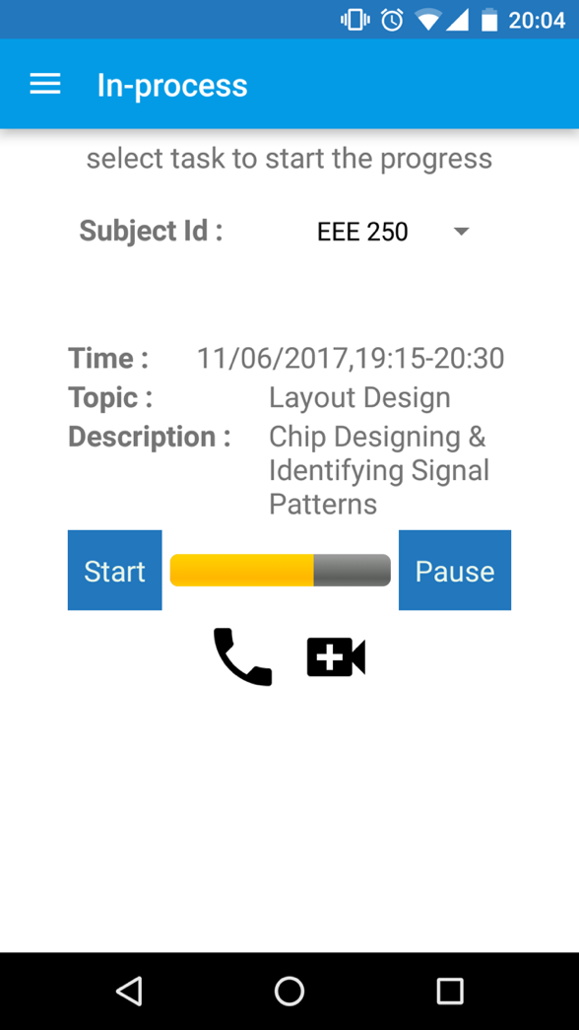 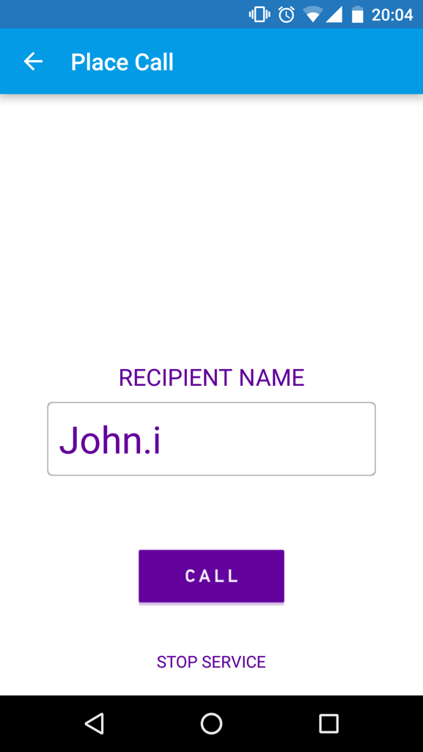

Figure 75. In-Process schedule and Calling to an instructor

#### **View Grade**

The students can see a grade for the selected task of the subject. Moreover, as shown in Figure 76, the student can see the current grade for the selected subject. It is an average grade for the student, not a final aggregated grade. To view their grades for their enrolled courses, the student must go to the “Grade” tab from the “Sidebar Menu”. Here the student can see a list of subjects, and the student can select a subject and will then see their grades for each session. If a grade is not assigned for a session, then the student will see a “Not Graded” status notification.

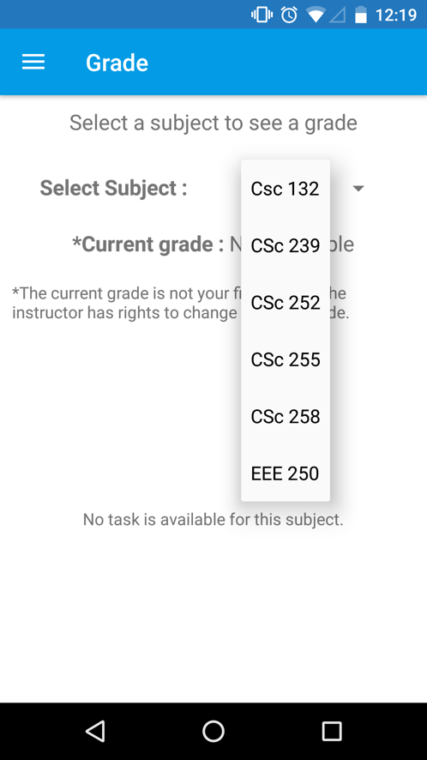 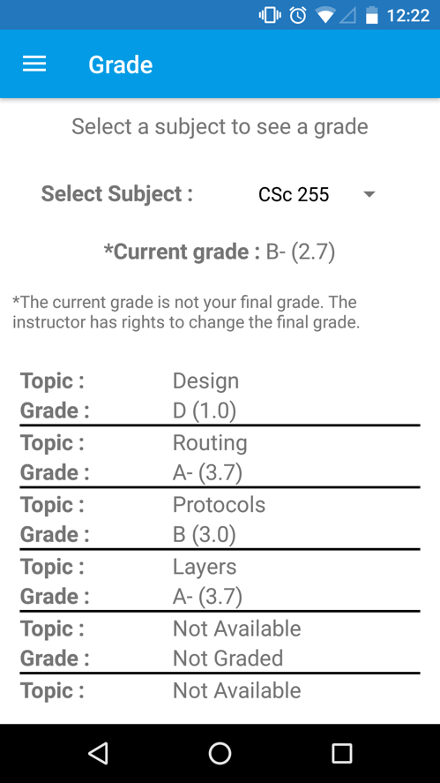

Figure 76. Displaying a list of grades for the selected subject

#### **Message**

As shown in Figure 77, the logged-in user can connect with other users via email. Upon selecting the “Message” tab, the logged-in user can search for other users. Upon selecting desired recipient of the message, the selected user will appear in the “To” box. To remove the user from “To” box, the logged in user can press the “x” button associated with each user tag. When the send button from the top right corner is pressed, the user will be navigated to the Gmail application installed in the device.

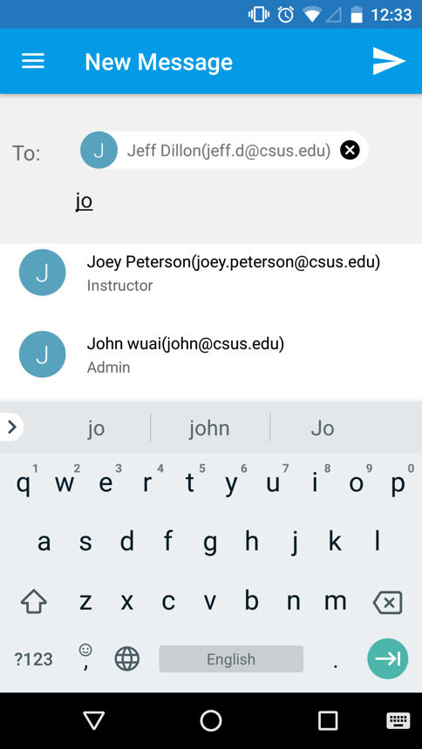 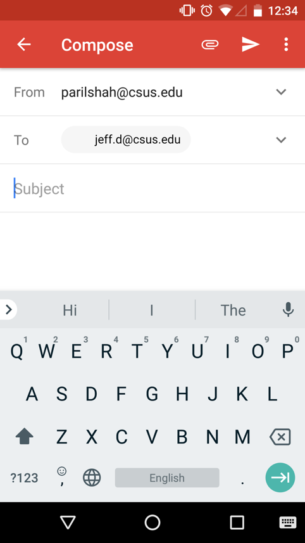

Figure 77. New message

#### **Change Password**

A user can change a password of the account from the “Change Password” tab. Here a user has to write a new password and confirm the new password. The validation here is that both fields should be equal. To finalize, press the “✓” button on the right top corner.

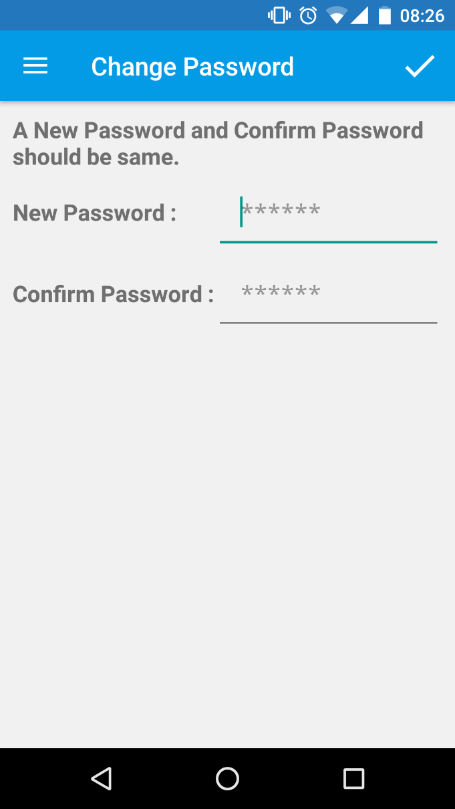

Figure 78. Change password

As shown in Figure 79, the API, @POST("api/Register/PostRegisterPassUpdate"), is called for changing the password for the logged-in user.

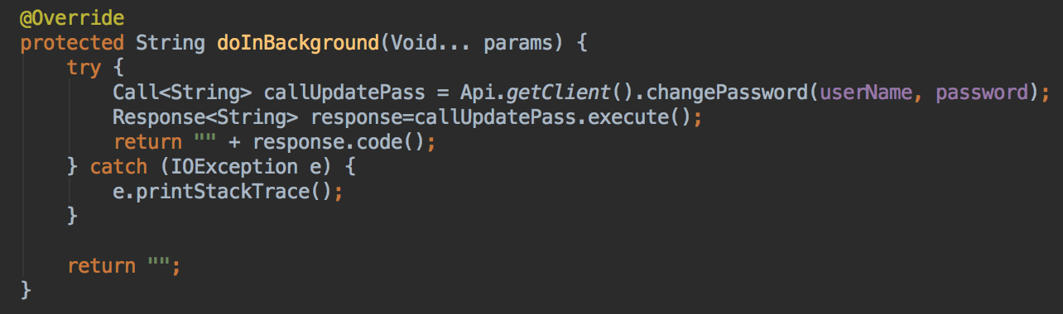

Figure 79. Snippet for calling an API for changing a password for the user from MLAEditPasswordFragment.java

#### **Source code summary, functionalities & API for Student module**

In the following table, there is a list of files along with the brief description of functionalities and API calls they executes. The all files are developed for a student module.

|  |  |  |
| --- | --- | --- |
| **Source Code** | **Functionalities** | **API calls** |
| 🡪MLALoginActivity.java | For Login Screen | - /Register/GetRegisterAuth |
| 🡪MLAHomeActivity.java  🡪MLAStudentSubjectViewFragment.java.java | Displaying a list of enrolled subjects | -/Subject/  GetSubjectByStudent |
| 🡪MLAMyInformationFragment.java | Displaying the admin information | -/Admin/  GetAdminByUserName |
| 🡪MLASubjectViewFragment.java | - Displaying a list of all the subjects | - /Subject/GetAllSubject |
| 🡪MLAInProgressTasksFragment.java  🡪MLATaskViewFragment.java  🡪CallStudentActivity.java  🡪PlaceCallActivitiy.java  🡪AudioPlayer.java  🡪CallScreenActivity.java  🡪IncomingCallScreenActivity.java  🡪LoginActivity.java  🡪SinchService.java  🡪VideoCallScreenActivity.java | - Displaying In-Process lectures.  - Displaying a schedule for a course.  - Place an Audio call or Video call between Instructor and Student | -/Subject/  GetSubjectByStudent  -/Tasks/  GetTasksByStudent |
| 🡪 MLAGradeStudentViewFragment.java  🡪 MLAGradeStdDisplayAdapter.java | - Displaying a grade for all the enrolled courses. | -/Tasks/  GetTasksByStudent  - /Subject/  GetAllSubjectWithTask |
| 🡪 MLANewMessageFragment.java | - For sending a new message to the selected user. | - /Admin/GetAllAdmin  - /Instructor/GetAllInstructor  - /Student/GetAllStudent |
| 🡪MLAEditPasswordFragment.java | -For updating the existing password for an admin. | - /Register/  PostRegisterPassUpdate |

Table 6. Code Summary for Student module

## Server End Implementation

The Frontend has been discussed in the previous sections, and now the backend server configuration will be discussed. In this section, the step by step process for setting up the server side configuration along with database connection will be discussed. As the project focused is at the building frontend, only the setup for the backend will be covered. The RESTful API and database are hosted at the Amazon EC2 and Amazon RDS respectively.

The following are the two programs which need to be downloaded and installed in order to setup the server side functionality.

* SQL Server Management Studio: Setting up the database and tables for accessing the data from database server Amazon RDS.
* Microsoft Visual Studio 2012: For publishing the web API to Amazon EC2.

### **Connect Database from SSMS**

As shown in Figure 80, on the left side pane, the user can click “Connect” and then select “Database Engine” to connect to the Amazon RDS, so the user can see the database on the local machine.

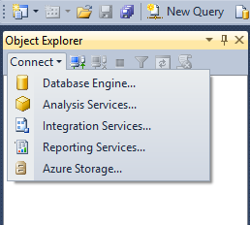

Figure 80. Select Database Engine for connecting to Amazon RDS

Figure 81 shows how to add server name, the URL of Amazon RDS instance has been copied from the AWS portal. Adding an authentic username and password will allow a user to view database.

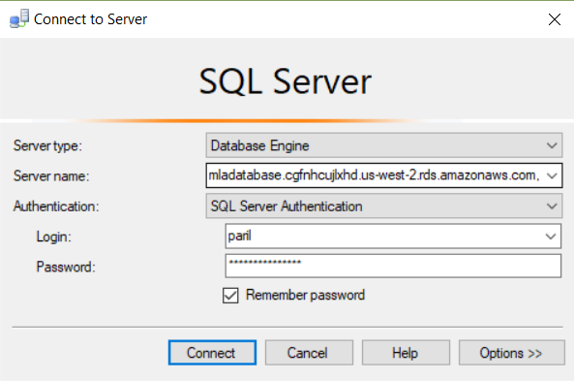

Figure 81. Connecting to SQL server

### **View Database**

Figure 82 shows the database for the Mobile Learning Application. The tables are used to store the data via RESTful API. Here the user can execute different database queries. The result will appear in the table format.

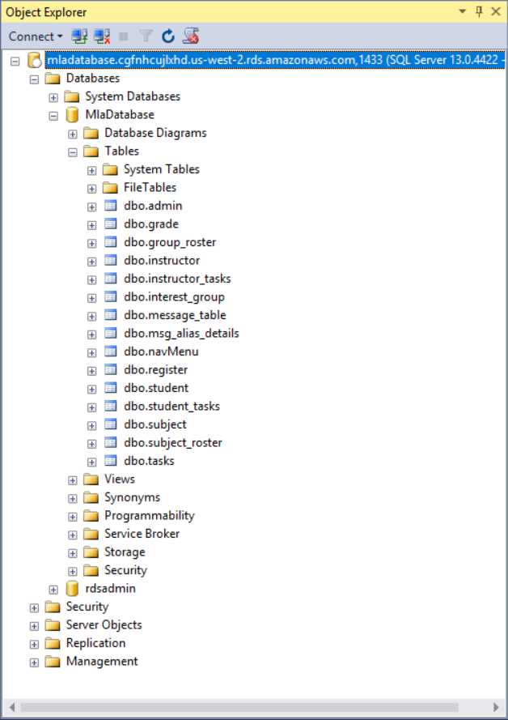

Figure 82. View Database

### **Add a data connection from Visual Studio 2012**

* In “Server Explorer”, right click on the data connection and select “add a connection”.
* As shown in Figure 83, from the ‘Data Source’ dialog box, change ‘Data Source’ to ‘Microsoft SQL Server’.

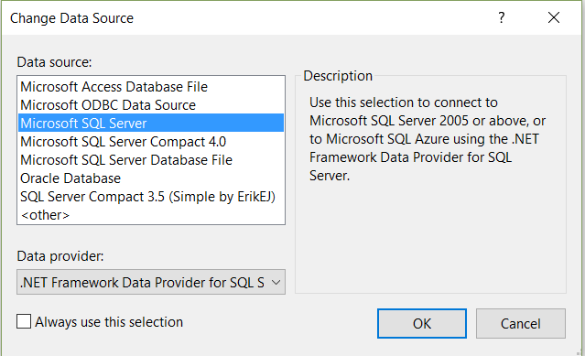 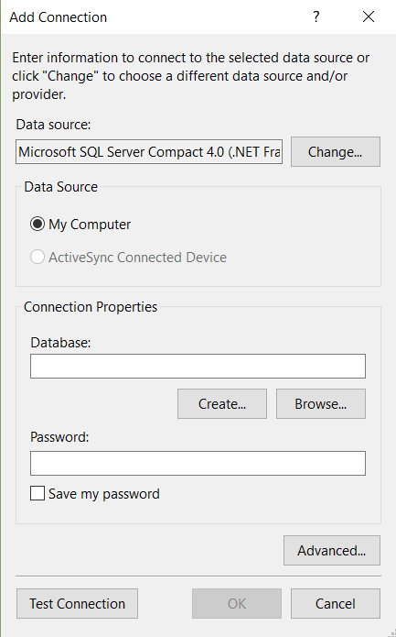

Figure 83. Add connection and change data source

* As shown in Figure 84, select the Server Name from dropdown menu.
* As shown in Figure 84, add the username and password for the selected server, and press “Test Connection”.

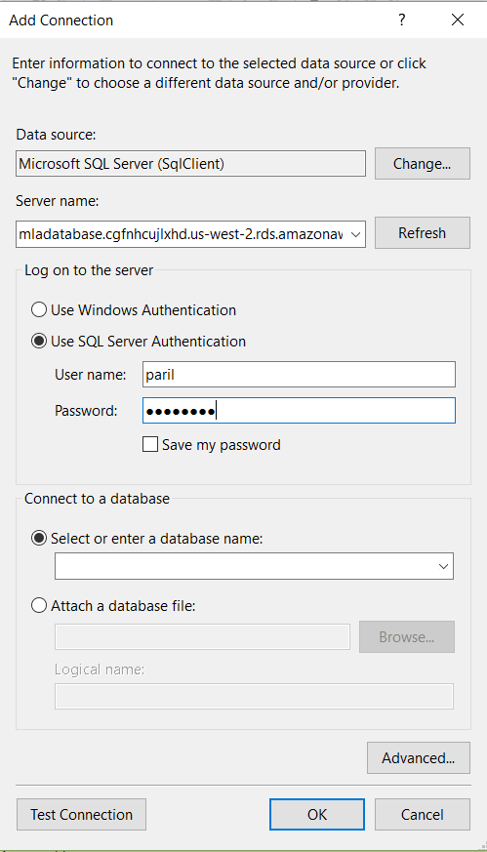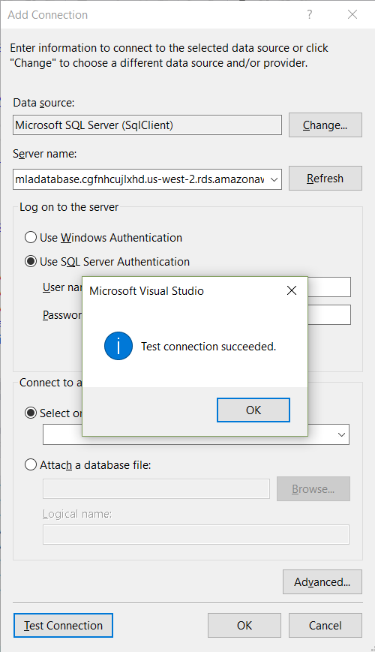

Figure 84. Selecting a database and test connection

### **Publish Web API from Microsoft Visual Studio 2012**

#### **Publish**

As illustrated in Figure 85, from “Solutions Explorer”, click right on “MlaWebApi”, and then select “Publish”.

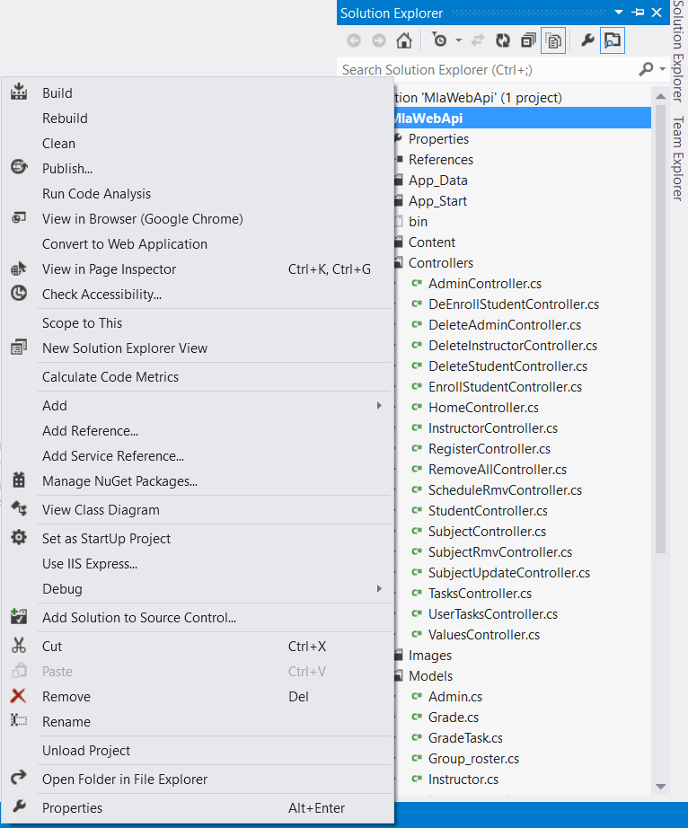

Figure 85. Publishing Database using visual studio

#### **Profile Name**

As shown in Figure 86, select profile name.

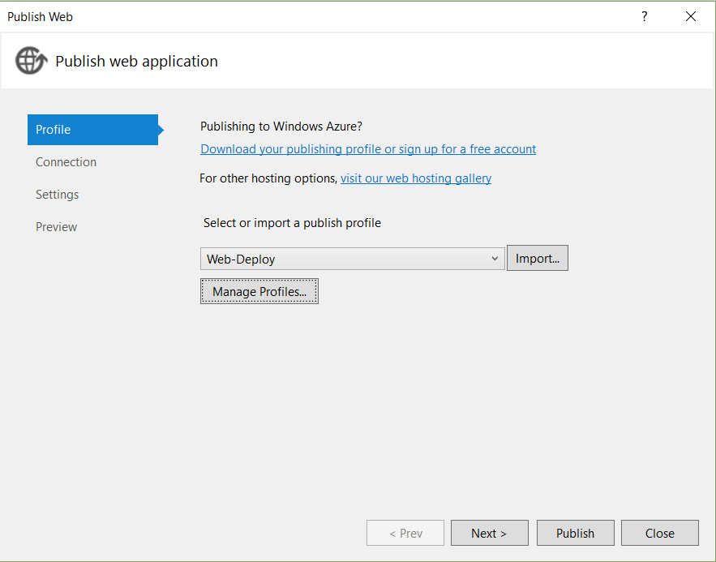

Figure 86. Providing profile name

As shown in Figure 87, select “Connection”. Then add the service URL, Username, and Password. Here it shows the server URL from Amazon EC2 because the server will be hosted there.

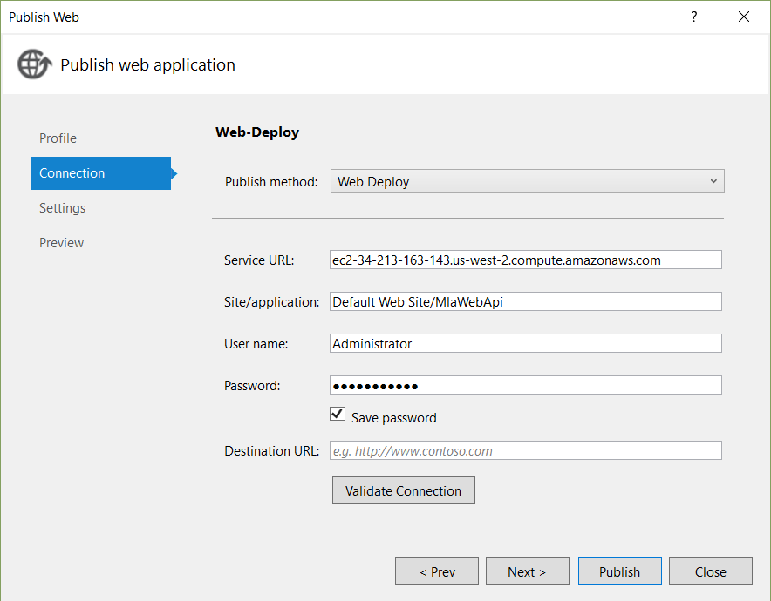

Figure 87. Providing a Service URL and credentials

As shown in Figure 88, the configuration should be “Release” and add the Database URL. Then press the “Publish” button.

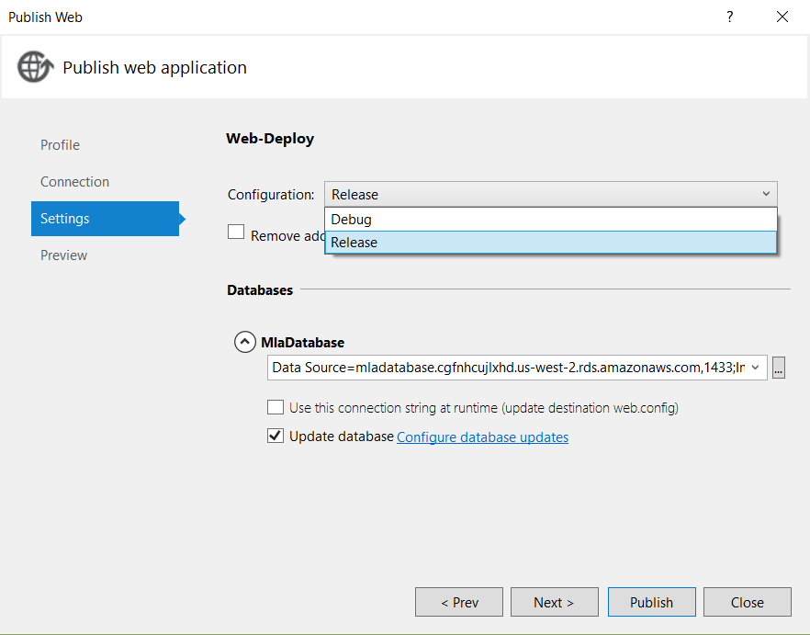

Figure 88. Web publish settings

As shown in Figure 89, the RESTful API has been published successfully to Amazon EC2.

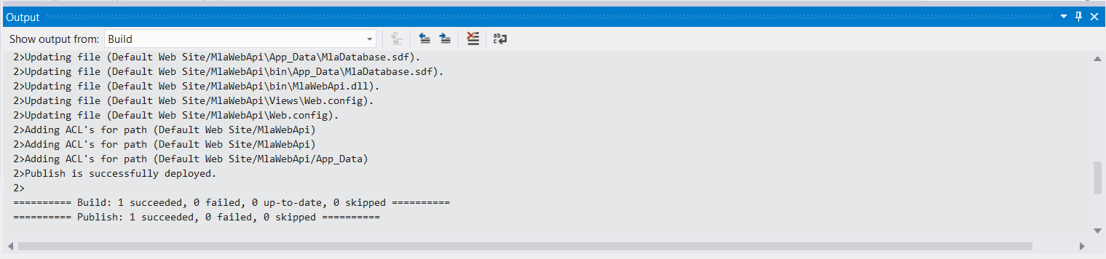

Figure 89. Output of Successful web publish

#### **Source code summary, functionalities & methods for Server module**

In the following table, there is a list of files along with the brief description of functionalities and API calls they executes. All of the files are developed for a server side module.

|  |  |  |
| --- | --- | --- |
| **Source Code** | **Functionalities** | **Endpoint / Method** |
| 🡪 AdminController.cs | - Fetch a list of Admins.  - Update the admin information. | - GetAllAdmin()  - PostAdminUpdate(Admin admin) |
| 🡪 DeEnrollStudentController.cs | - Fetch a list of disenrolled students. | - GetDeEnrollBySubject  (string idSubject) |
| 🡪 DeleteAdminController.cs | - Remove an Admin | - PostAdminRmv(string idAdminRmv) |
| 🡪 DeleteInstructorController.cs | - Remove an Instructor | - PostInstructorRmv(string idInstructorRmv) |
| 🡪 DeleteStudentController.cs | - Remove a Student | - PostStudentRmv(string idStudentRmv) |
| 🡪 EnrollStudentController.cs | - Fetch a list of enrolled students. | - GetEnrollBySubject(string idSubject) |
| 🡪 InstructorController.cs | - Fetch a list of Instructors.  - Update the instructor information. | - GetAllInstructor()  - PostInstructorUpdate  (Instructor instructor) |
| 🡪 RegisterController.cs | - Add a new admin.  - Add a new instructor.  - Add a new student.  - Login  - Update Password. | - PostAddAdmin(string adminUserName, string adminPassword, string adminFirsName, string adminLastName, string adminTelephone, string adminAddress, string adminAliasMailId, string adminEmailId, string adminSkypeId)  - PostAddStudent(string userName, string password, string firsName, string lastName, string telephone, string address, string aliasMailId, string emailId, string skypeId)    - PostAddInstructor(string instUserName, string instPassword, string instFirsName, string instLastName, string instTelephone, string instAddress, string instAliasMailId, string instEmailId, string instSkypeId)  - PostRegisterPassUpdate  (string userName, string password)  - GetRegisterAuth(string userName,string password) |
| 🡪 ScheduleRmvController.cs | - Remove all tasks for a specific subject | - PostTaskRmv(string subject_id) |
| 🡪 StudentController.cs | - Fetch a list of Students.  - Update the student information. | - GetAllStudent()  - PostStudentUpdate(Student student) |
| 🡪 SubjectController.cs | - Fetch all the list of subjects.  - Fetch a list of all the subjects for a specific student.  - Add a new subject. | - GetAllSubject()  - GetSubjectByStudent(string idStudent)  - PostSubject(Subject subject) |
| 🡪 SubjectRmvController.cs | - Remove a subject. | -PostSubjectRmv(string subject_id) |
| 🡪 SubjectUpdateController.cs | - Update the information of a course. | -PostSubjectUpdate(Subject subject) |
| 🡪 TasksController.cs | - Get all the sessions of the subject.  - Get all the tasks for the subject.  - Get all the grades for the completed tasks.  - Edit a grade of the student.  - Add a new schedule for a course.  - Delete a schedule for a course.  - Edit a schedule for a course. | - GetTasksBySubject(string subjectId)  - GetTasksByStudent(string studentId, string subject)  - GetStudentByTask(string task, string subjectid)  - PostGradeUpdate(string task_id, string student_id, string grade)  - PostTaskUpdate(string idTask, string topic,string description)  - PostTask(Tasks tasks)  - DeleteTask(string subject_id, string instructor_id) |

Table 7. Code Summary of API

# FUTURE WORK AND CONCLUSION

There are lots of prospects to enhance the application in the future, for example:

1. Add security by implementing HTTPS which creates secure session.
2. Multiple sessions for a course can be introduced.
3. The students can access the materials for the enrolled subjects.
4. The students can access the Grade Point Average (GPA) calculator.
5. Add visualization for reviewing performance of the students in a subject.

Thus, as per the goal, I have learned about Android application development, and also developed the application successfully. Also, I have experienced hands-on application development to learn more about the back end with setting up on Amazon EC2 and Amazon RDS.

# Bibliography

|  |  |
| --- | --- |
| [1] | V. Beal, "What is Entity Relationship Diagram? Webopedia Definition," [Online]. Available: https://www.webopedia.com/TERM/E/entity_relationship_diagram.html. [Accessed 10 November 2017]. |
| [2] | Dzonatas, "Systems_development_life_cycle," Own work, 13 07 2008. [Online]. Available: https://en.wikipedia.org/wiki/Systems_development_life_cycle. [Accessed 10 November 2017]. |
| [3] | Techopedia, "three-tier-architecture," Techopedia, [Online]. Available: https://www.techopedia.com/definition/24649/three-tier-architecture. [Accessed 30 October 2017]. |
| [4] | Google, "Android Studio Features," Google, 10 2017. [Online]. Available: https://developer.android.com/studio/features.html. [Accessed 15 June 2017]. |
| [5] | Udacity, "new-android-fundamentals," Udacity, Inc, [Online]. Available: https://www.udacity.com/course/new-android-fundamentals--ud851. [Accessed 1 June 2017]. |
| [6] | Wikipedia, ".NET_Framework," [Online]. Available: https://en.wikipedia.org/wiki/.NET_Framework. [Accessed 08 November 2017]. |
| [7] | E. H. S. W. Margaret Rouse, "RESTful-API," TechTarget, 12 2016. [Online]. Available: http://searchmicroservices.techtarget.com/definition/RESTful-API. [Accessed 05 November 2017]. |
| [8] | Amazon, "Elastic Compute Cloud (EC2) - Cloud Server & Hosting - AWS," Amazon, [Online]. Available: https://aws.amazon.com/ec2/. [Accessed 17 July 2017]. |
| [9] | Microsoft, "SQL Server Management Studio (SSMS) | Microsoft Docs," Microsoft, 02 02 2017. [Online]. Available: https://docs.microsoft.com/en-us/sql/ssms/sql-server-management-studio-ssms. [Accessed 08 November 2017]. |
| [10] | Amazon, "Amazon Relational Database Service (RDS) - AWS," Amazon, [Online]. Available: https://aws.amazon.com/rds/. [Accessed 17 July 2017]. |
| [11] | T. Dalling, "Model View Controller Explained - Tom Dalling," 31 05 2009. [Online]. Available: https://www.tomdalling.com/blog/software-design/model-view-controller-explained/. [Accessed 01 November 2017]. |
| [12] | Wideskills, "Introduction to MVC Architecture | Struts Tutorial by Wideskills," [Online]. Available: http://www.wideskills.com/struts/introduction-to-mvc-architecture. [Accessed July 2017]. |
| [13] | Wikipedia, "Adapter pattern - Wikipedia," [Online]. Available: https://en.wikipedia.org/wiki/Adapter_pattern. [Accessed August 2017]. |
| [14] | CodePath, "Using an ArrayAdapter with Listview . codepath/android_guides Wiki . Github," Codepath, [Online]. Available: https://github.com/codepath/android_guides/wiki/Using-an-ArrayAdapter-with-ListView. [Accessed 16 November 2017]. |
| [15] | Wikipedia, "Publish-Subscribe pattern - Wikipedia," [Online]. Available: https://en.wikipedia.org/wiki/Publish–subscribe_pattern. [Accessed October 2017]. |
| [16] | Google, "Environment - Material Design," Google, [Online]. Available: https://material.io/guidelines/material-design/environment.html#. [Accessed June 2017]. |
| [17] | Google, "Layouts | Android Developers," Google, [Online]. Available: https://developer.android.com/guide/topics/ui/declaring-layout.html. [Accessed June 2017]. |
| [18] | Sinch, "Sinch | Voice API, Verification & Cloud VoIP made Simple," Sinch, [Online]. Available: https://www.sinch.com/. [Accessed November 2017]. |